GitHub Tagging and Release

**Contents**

**Create repository** 3

**Create .gitignore file** 6

**Add collaborator** 8

**Add Milestones** 10

**Add Issue 1** 13

**Owner clone GitHub repository in eclipse** 16

**Clone Repository** 16

**Create maven project** 19

**Push Project to GitHub** 23

**Create Tag** 25

**Collaborator clone GitHub repository in eclipse** 29

**Collaborator invitation** 29

**Collaborator Clone Repository.** 29

**Import maven project** 31

**Collaborator Push Request** 36

**Collaborator Create Tag** 37

# 

# **Note: Please refer repository on github for reference implementation.**

https://github.com/CG-FS-ABL/Shipwreck_App.git

# **Create repository**



Owners create repository/file/Issues/milestones

1. Click on **new repository**

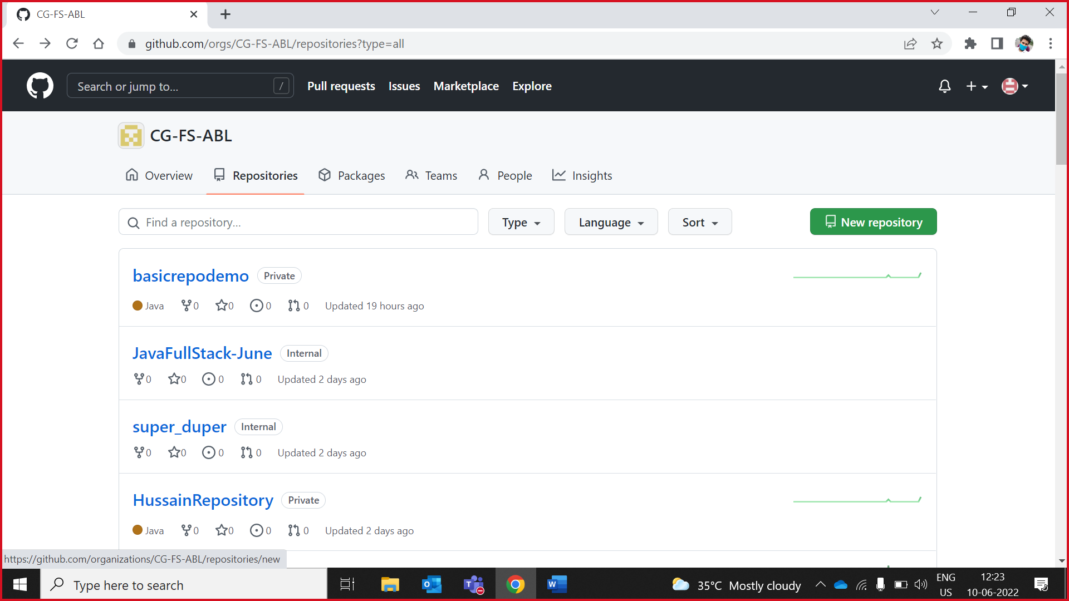

1. Select Owner from drop down as CG-FS-ABL, write repository name and make repository as **private**.

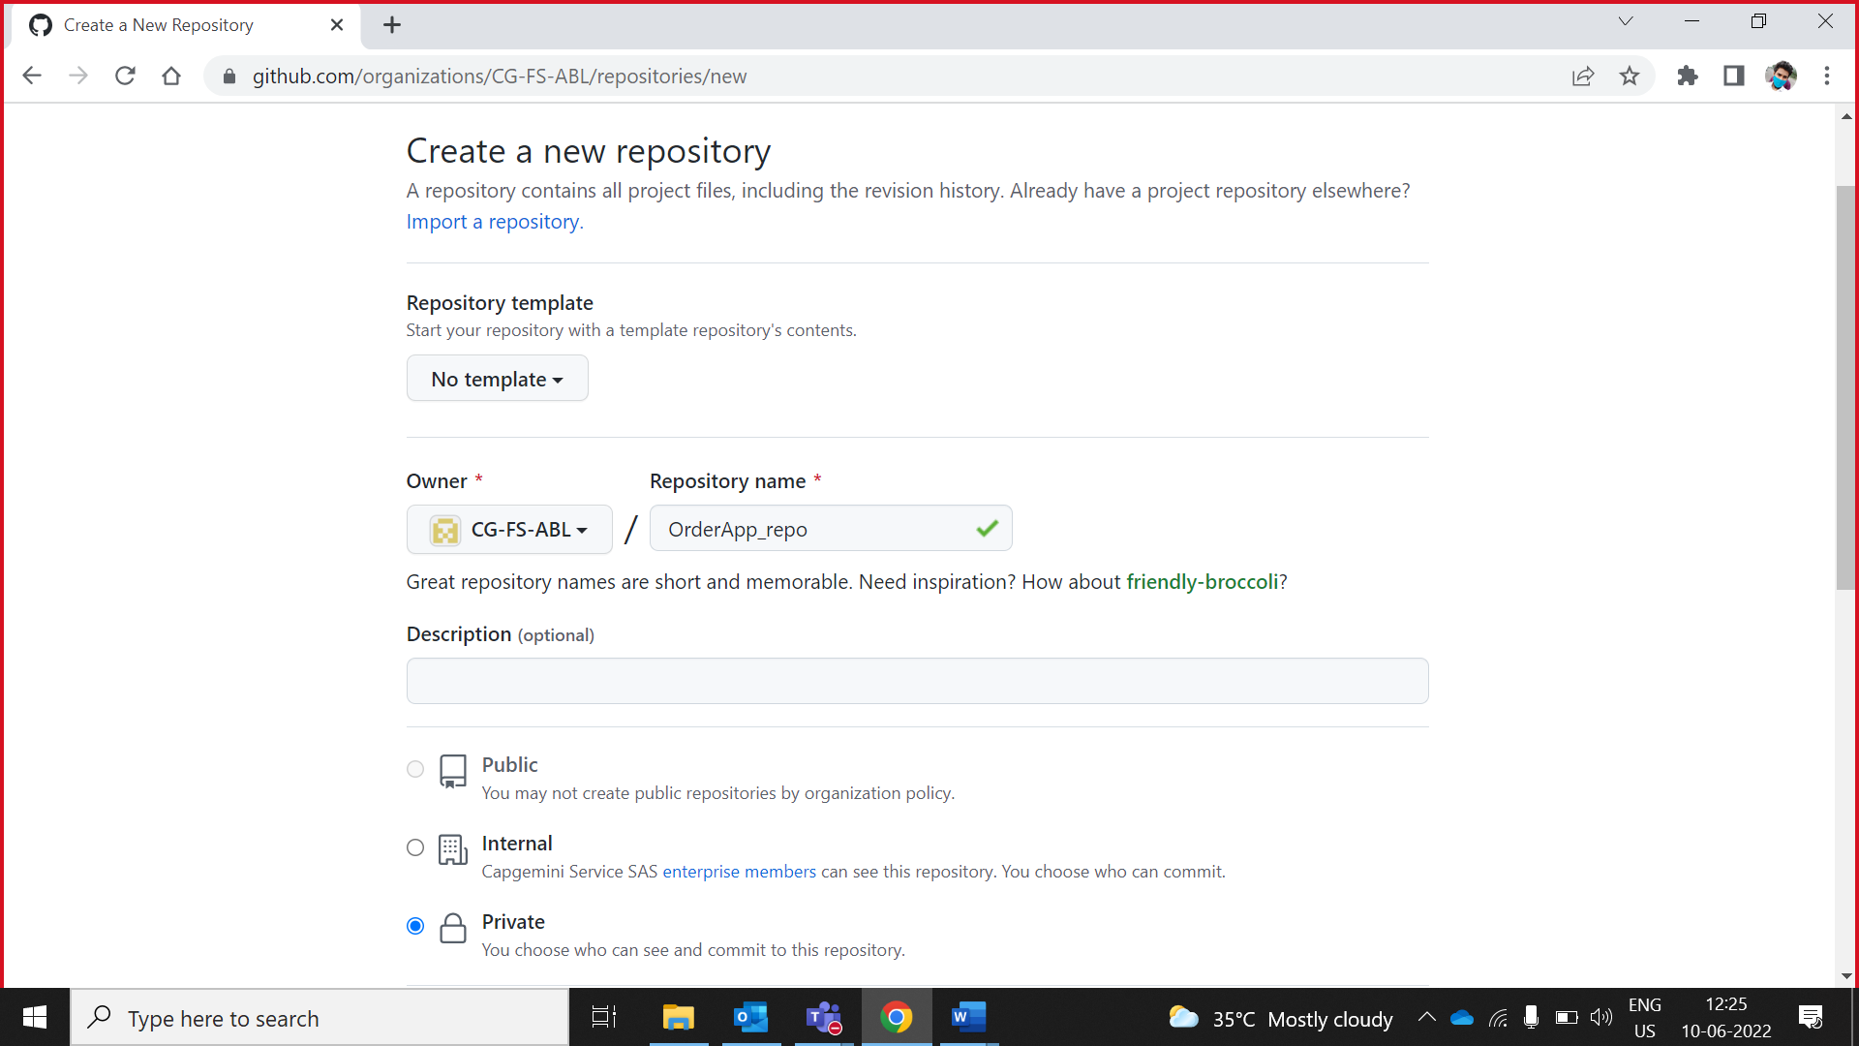

1. Check on **README** file and click on create repository

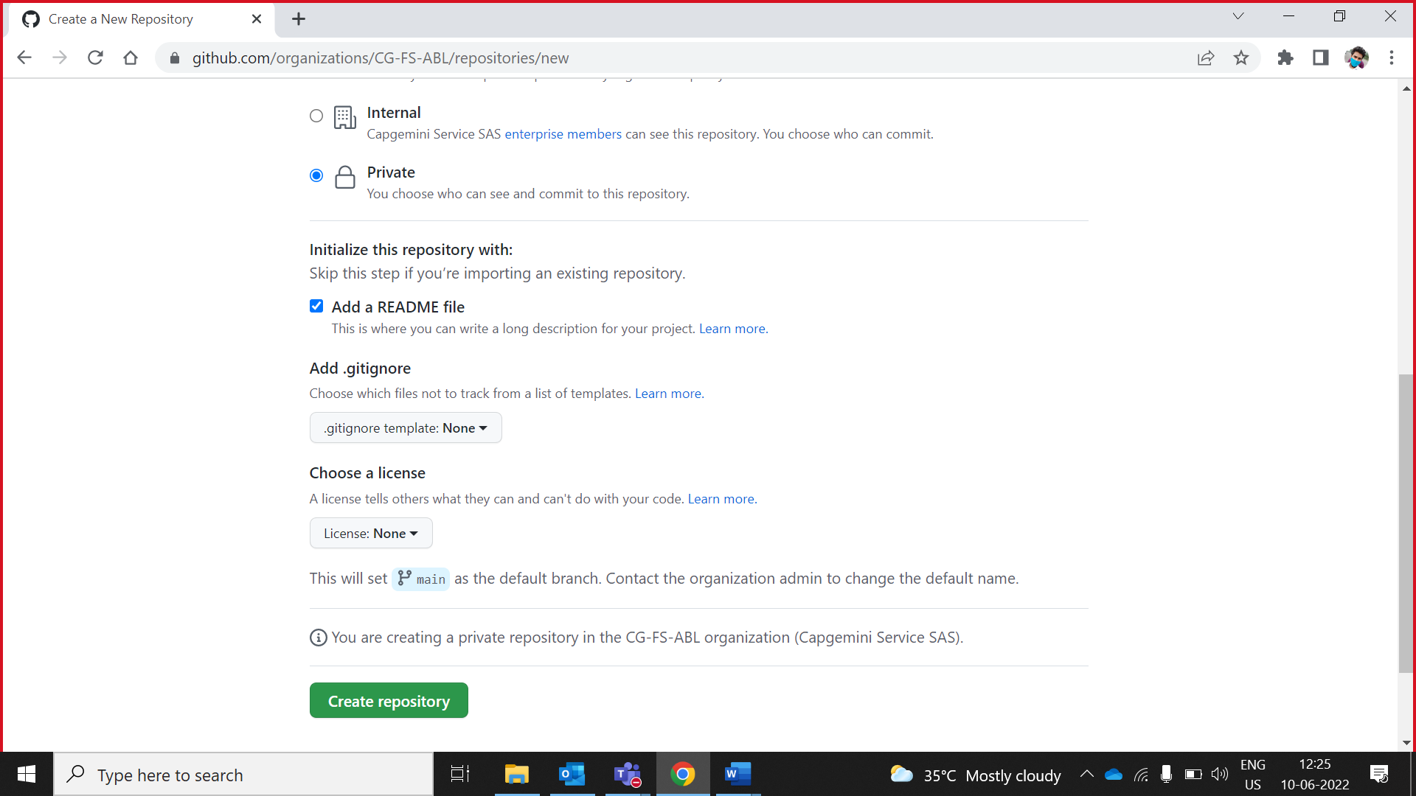

1. Edit **README.md**

Added README file on GitHub appears under the list of files in a repository.

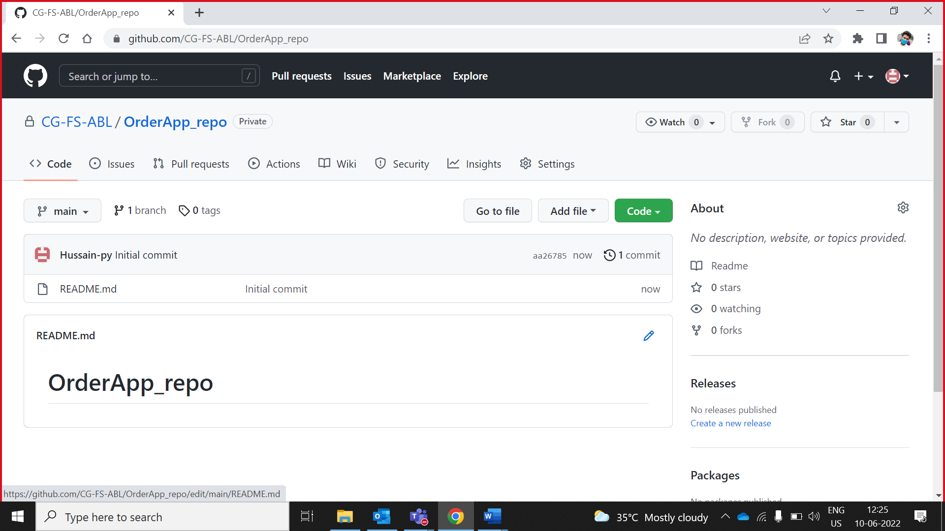

NOTE:  README is the first file one should read when starting a new project. It's a set of useful information about a project, and a kind of manual.

Edit Text

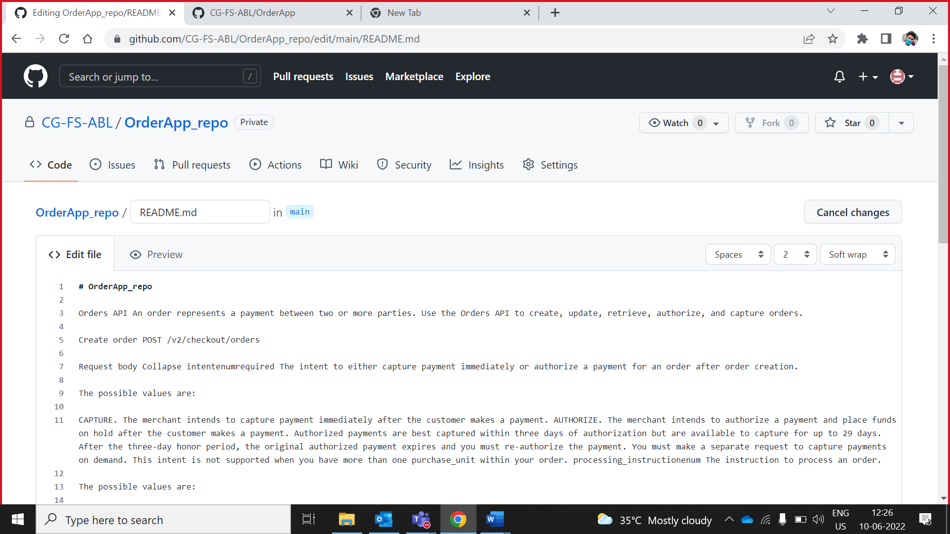

Preview text

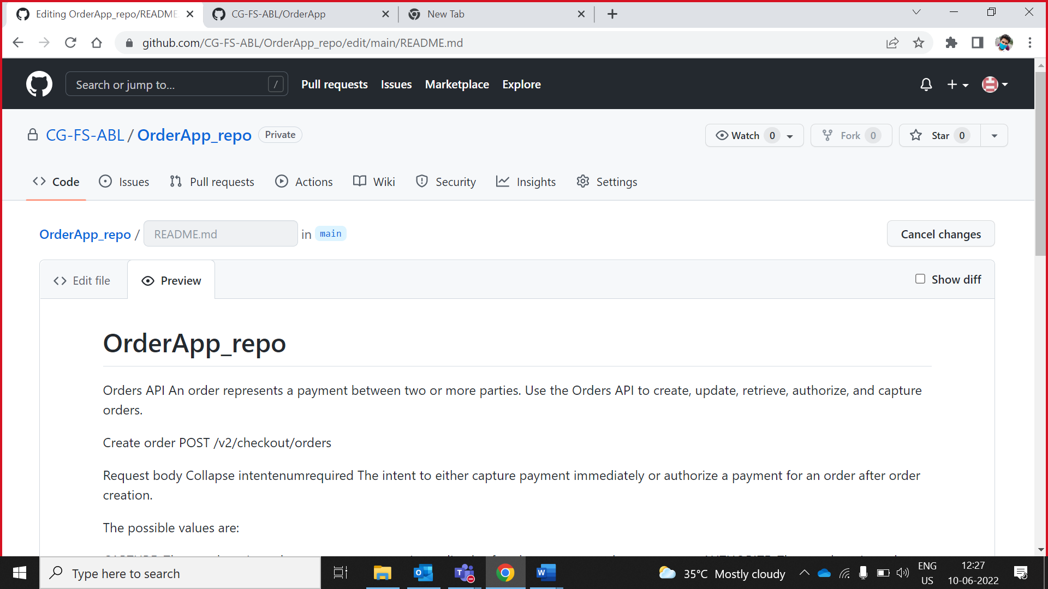

Commit README.md file changes

Commit **successfully**

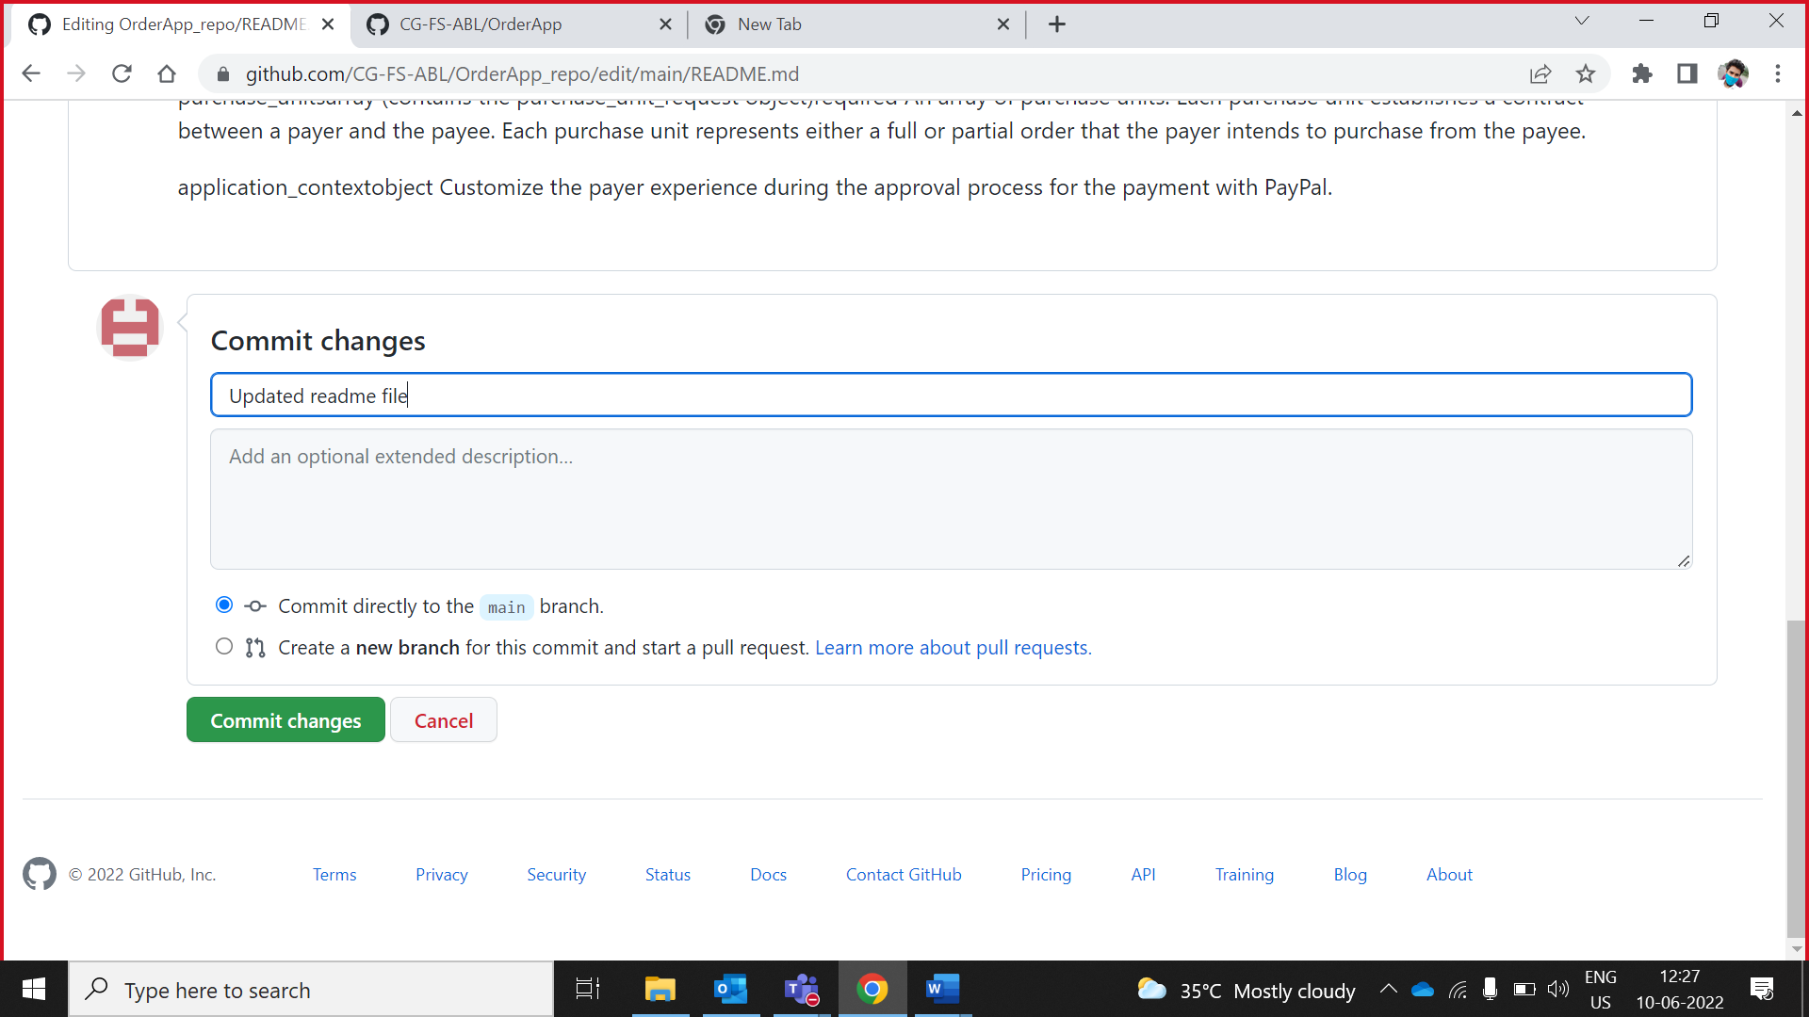

## **Create .gitignore file**

1. Click on Add files drop down and click on **create new file.**

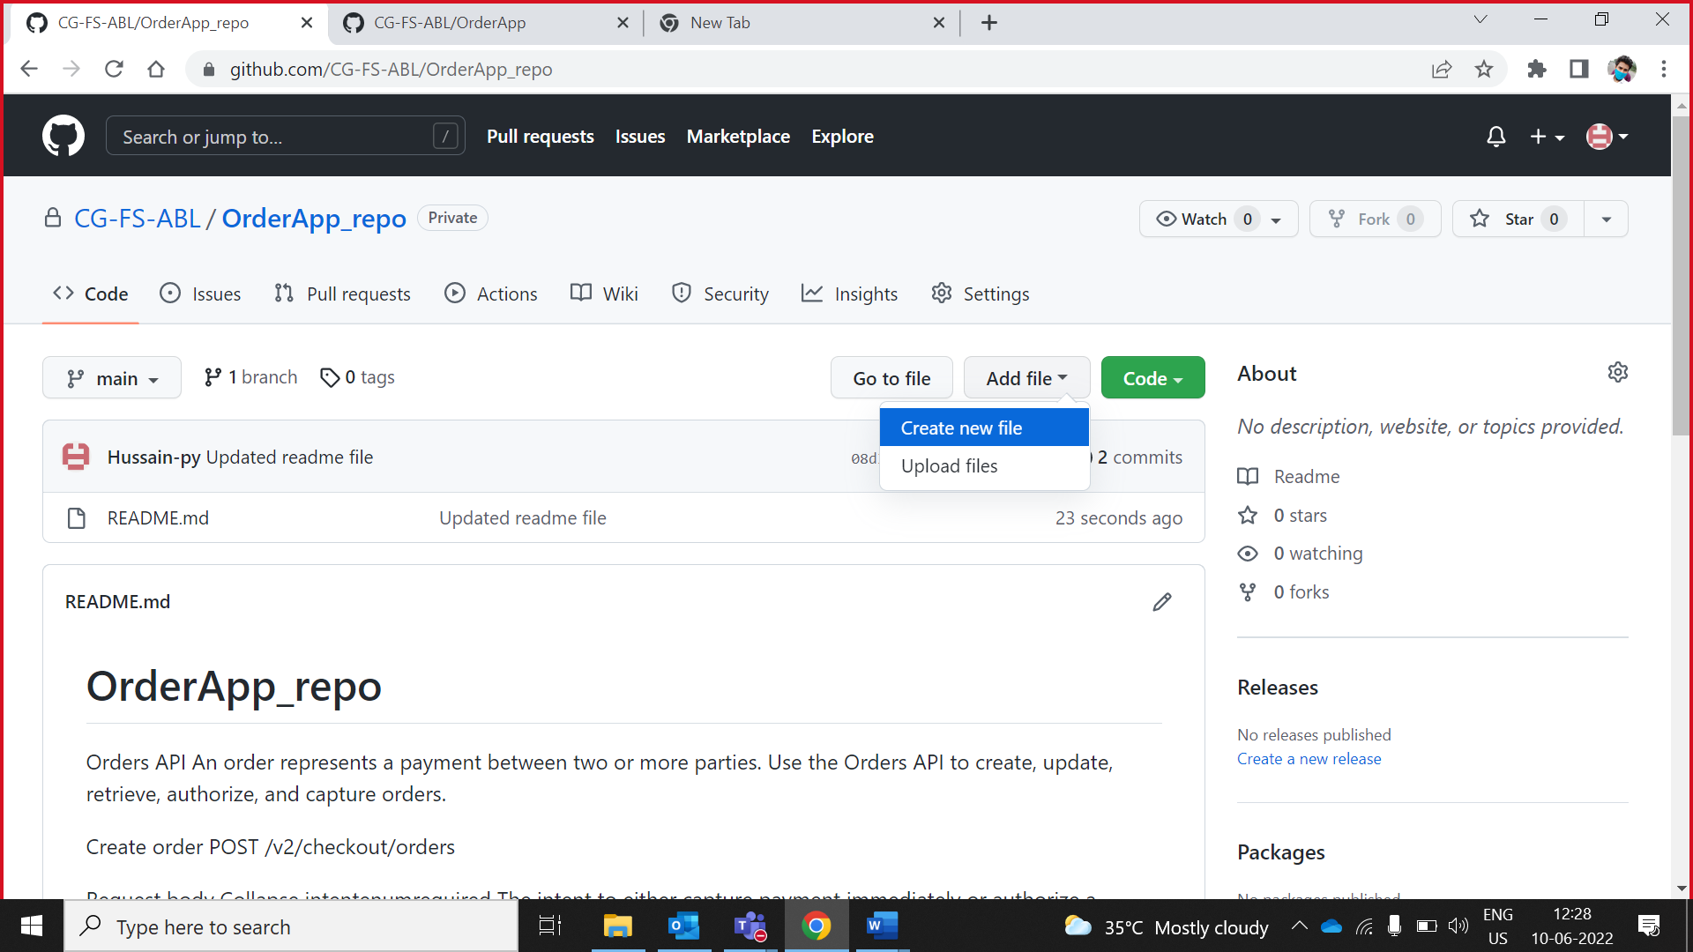

1. Write code on .gitignore (which is write in below image.)

NOTE **:**  . **gitignore** file is **a text file that tells Git which files or folders to ignore in a project.**

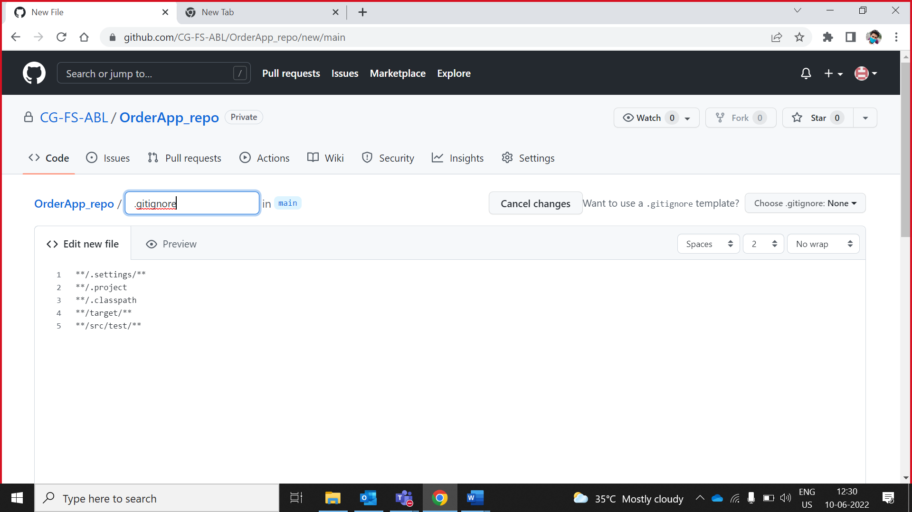

1. Write valid comment before commit the file and then click on **Commit new file.**

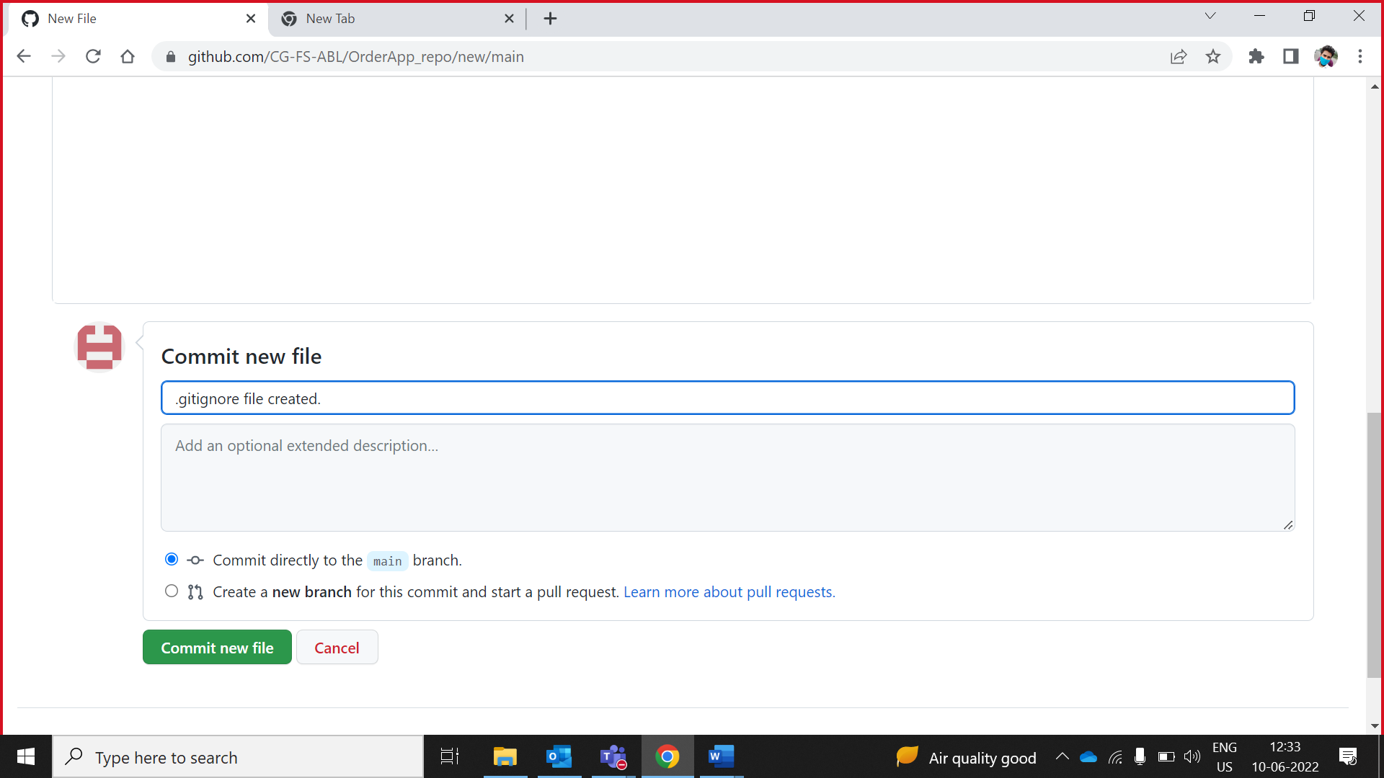

1. .gitignore file created successfully.

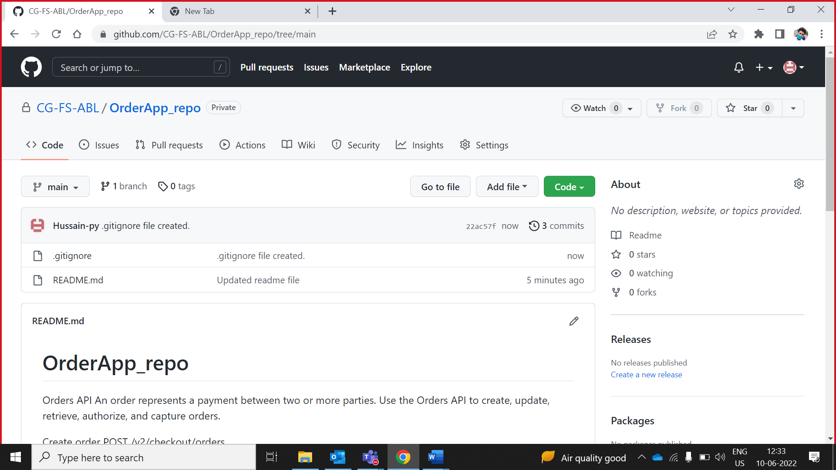

## **Add collaborator**

1. Go to settings

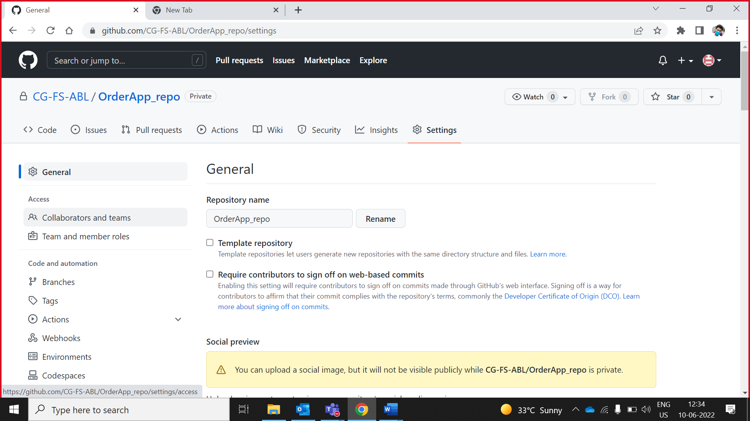

1. Go to collaborators and teams -- > add people

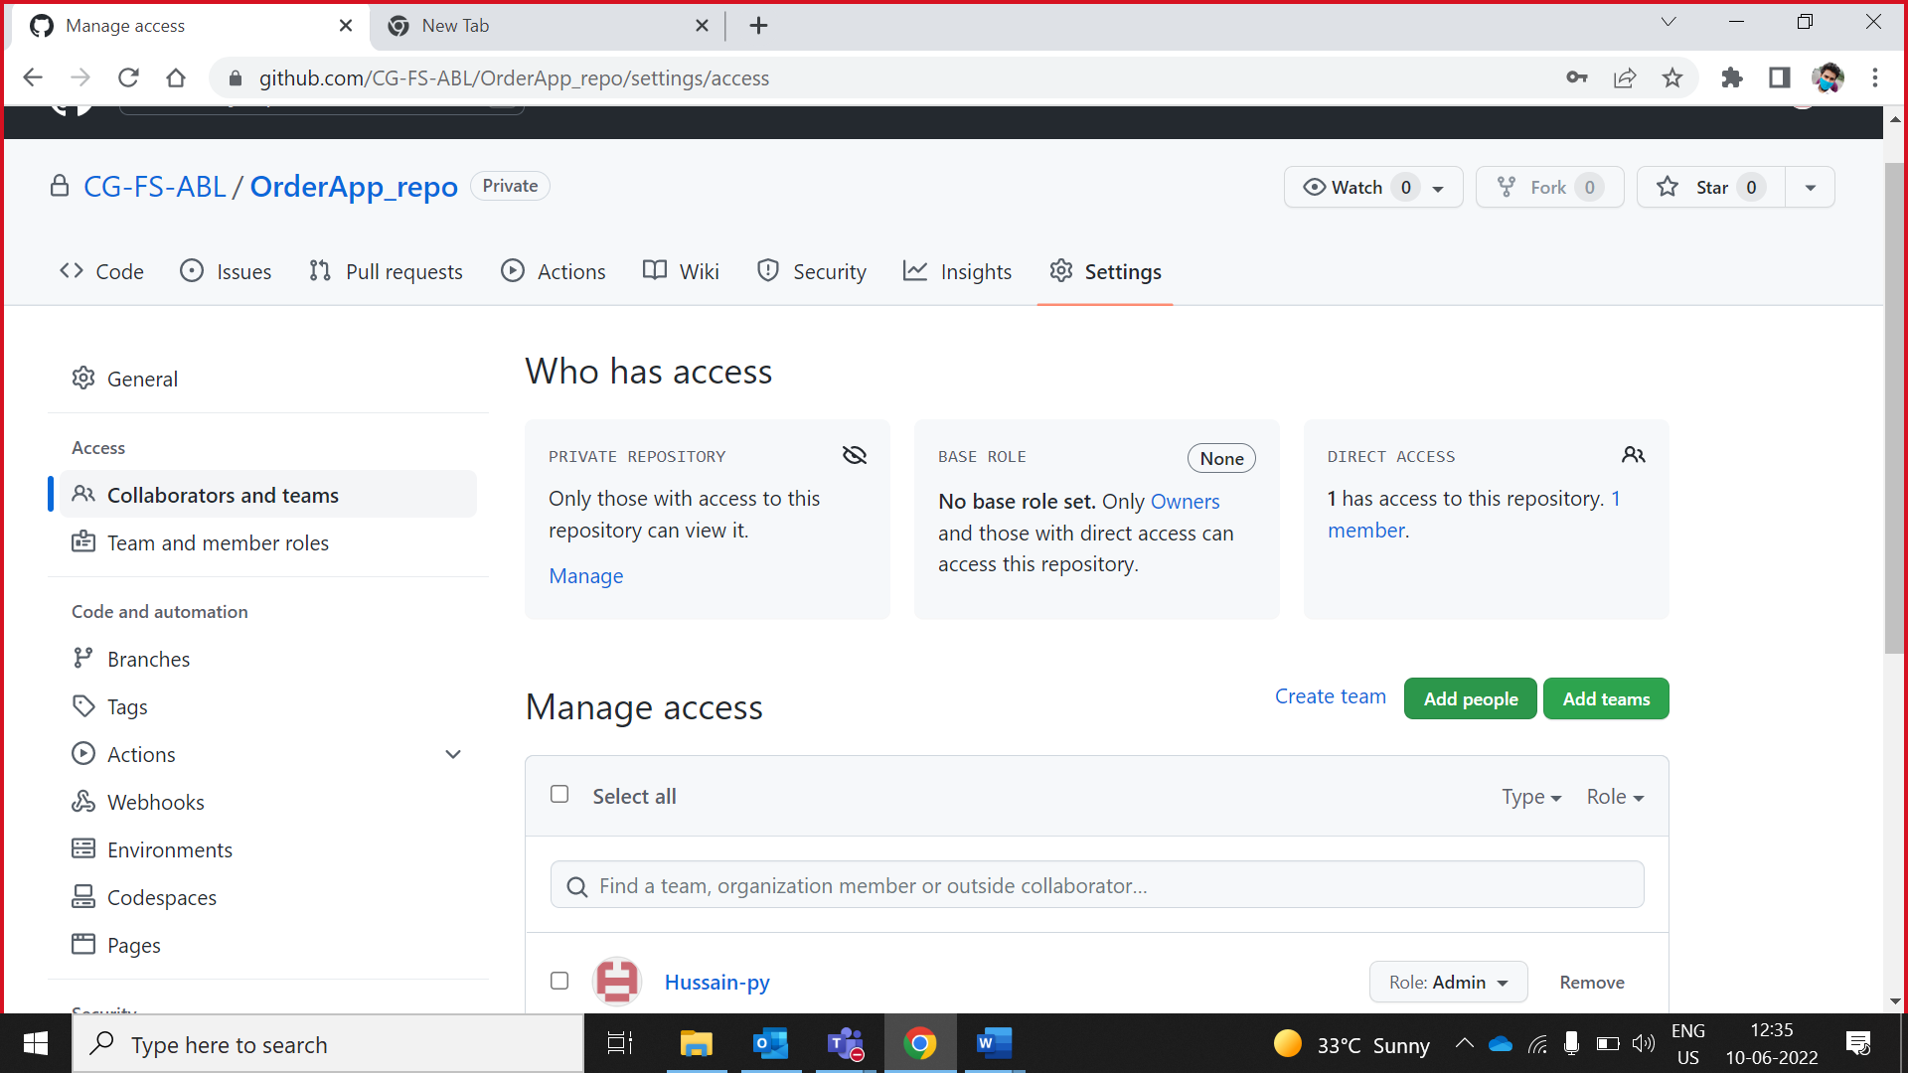

1. Search collaborators click on radio button write

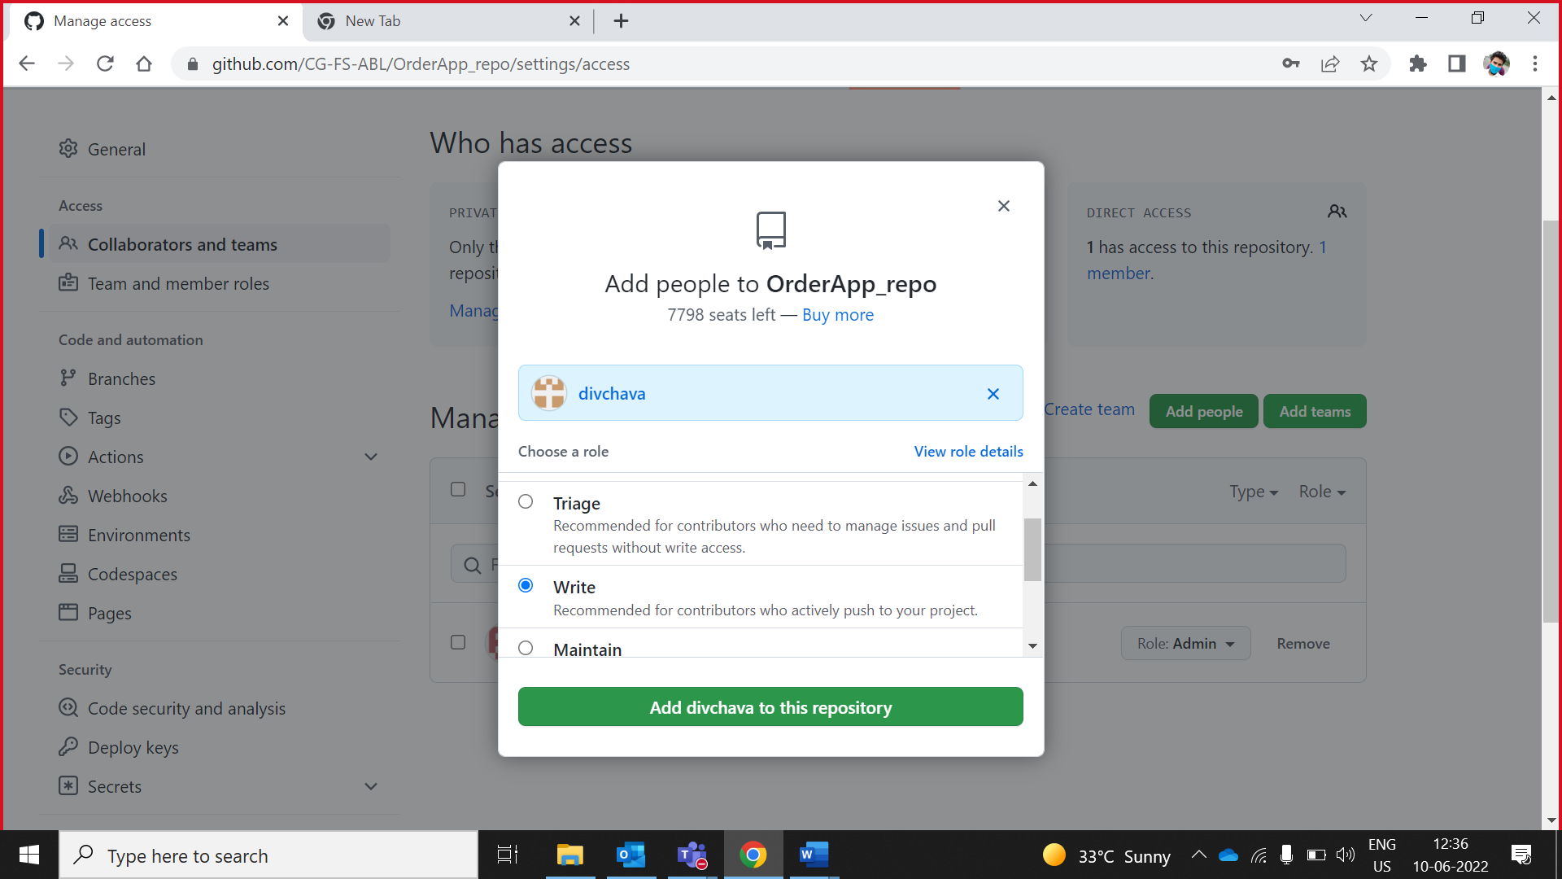

1. Collaborator added

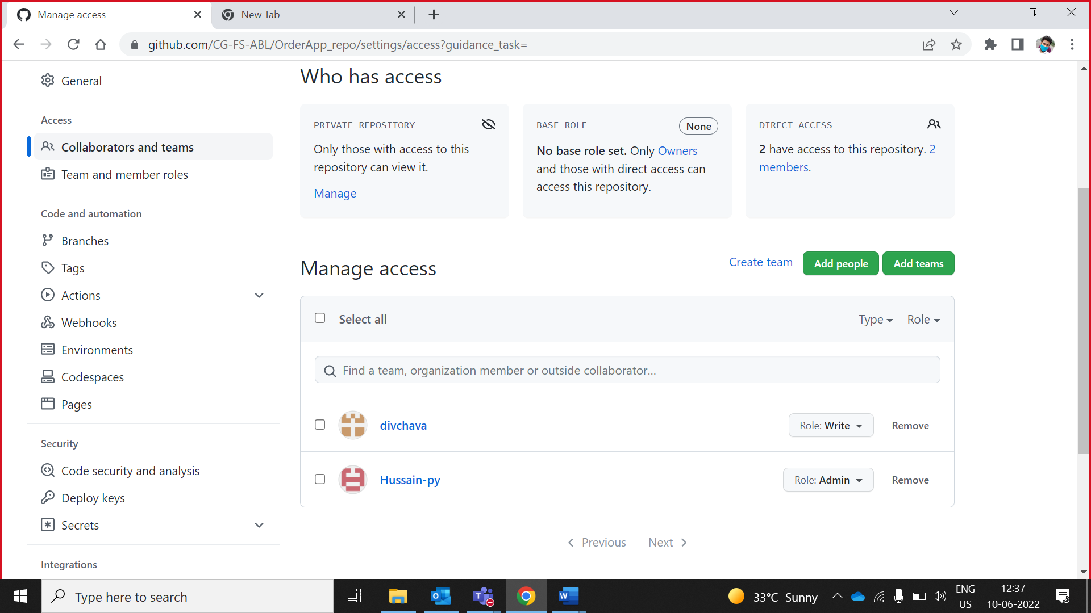

## **Add Milestones**

You can create a milestone to track progress on groups of issues or pull requests in a repository.

1. Click on issues, then click on milestones

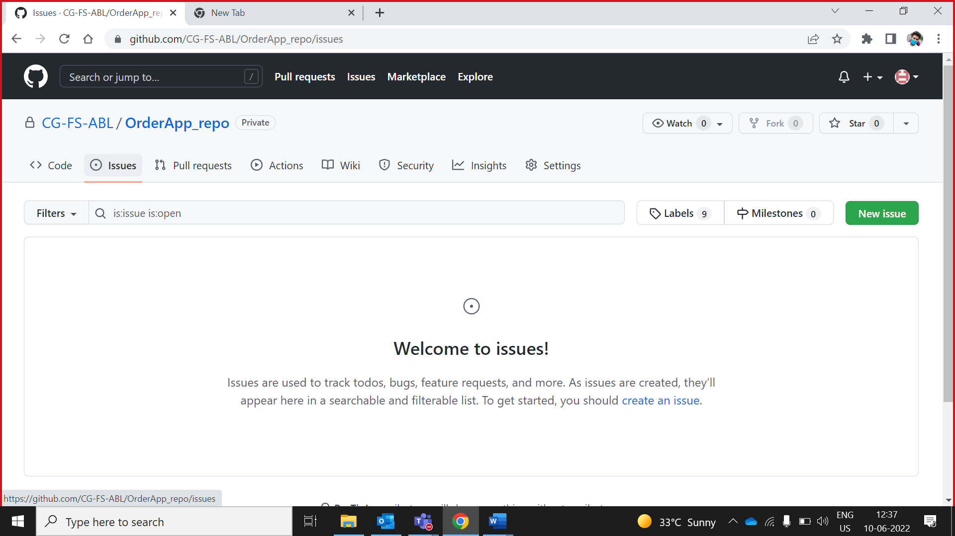

1. Click on create milestone

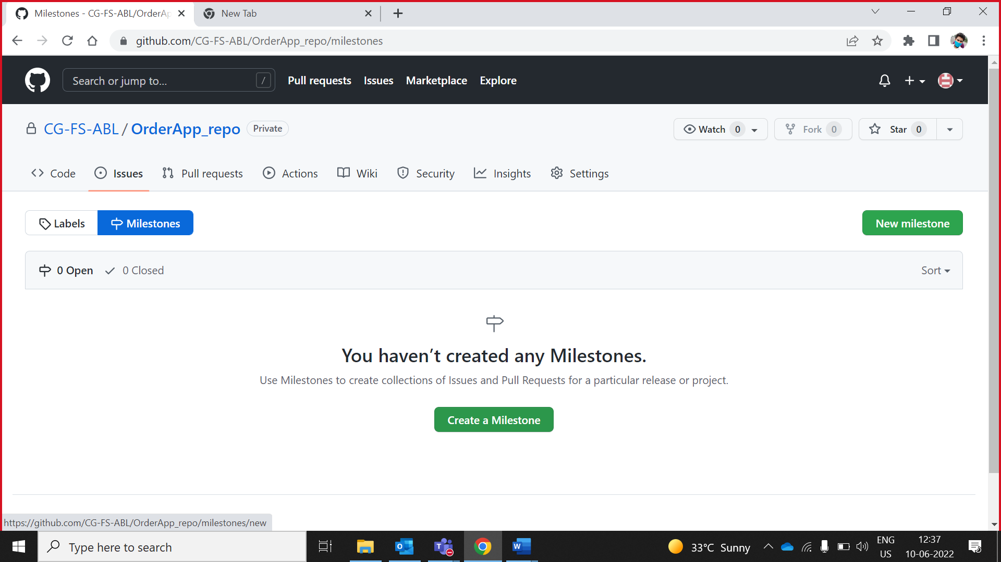

1. Type the milestone's title, description, or other changes, and click **Create milestone**.

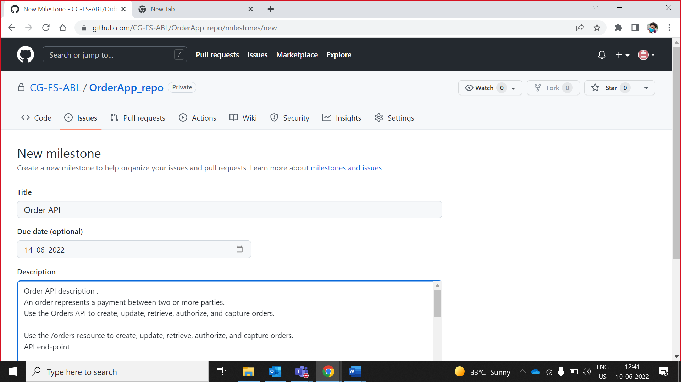

1. Click on **Create milestone.**

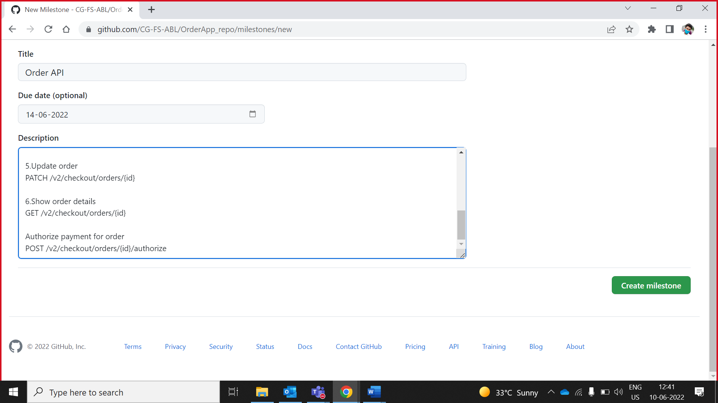

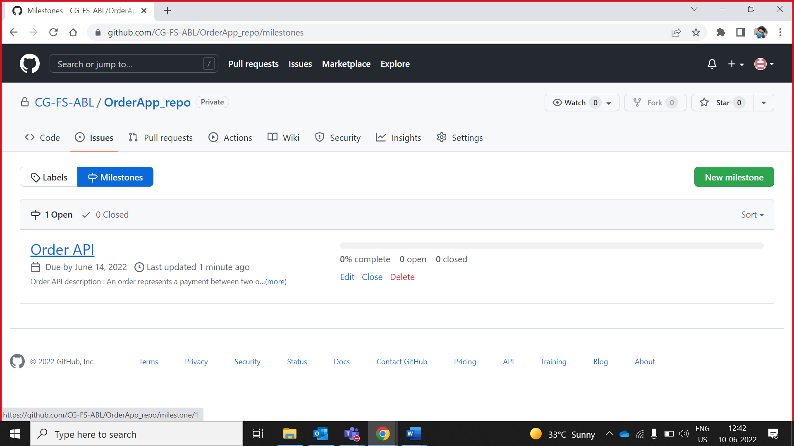

## **Add Issue 1**

1. Add Issue 1 click on **new Issue**

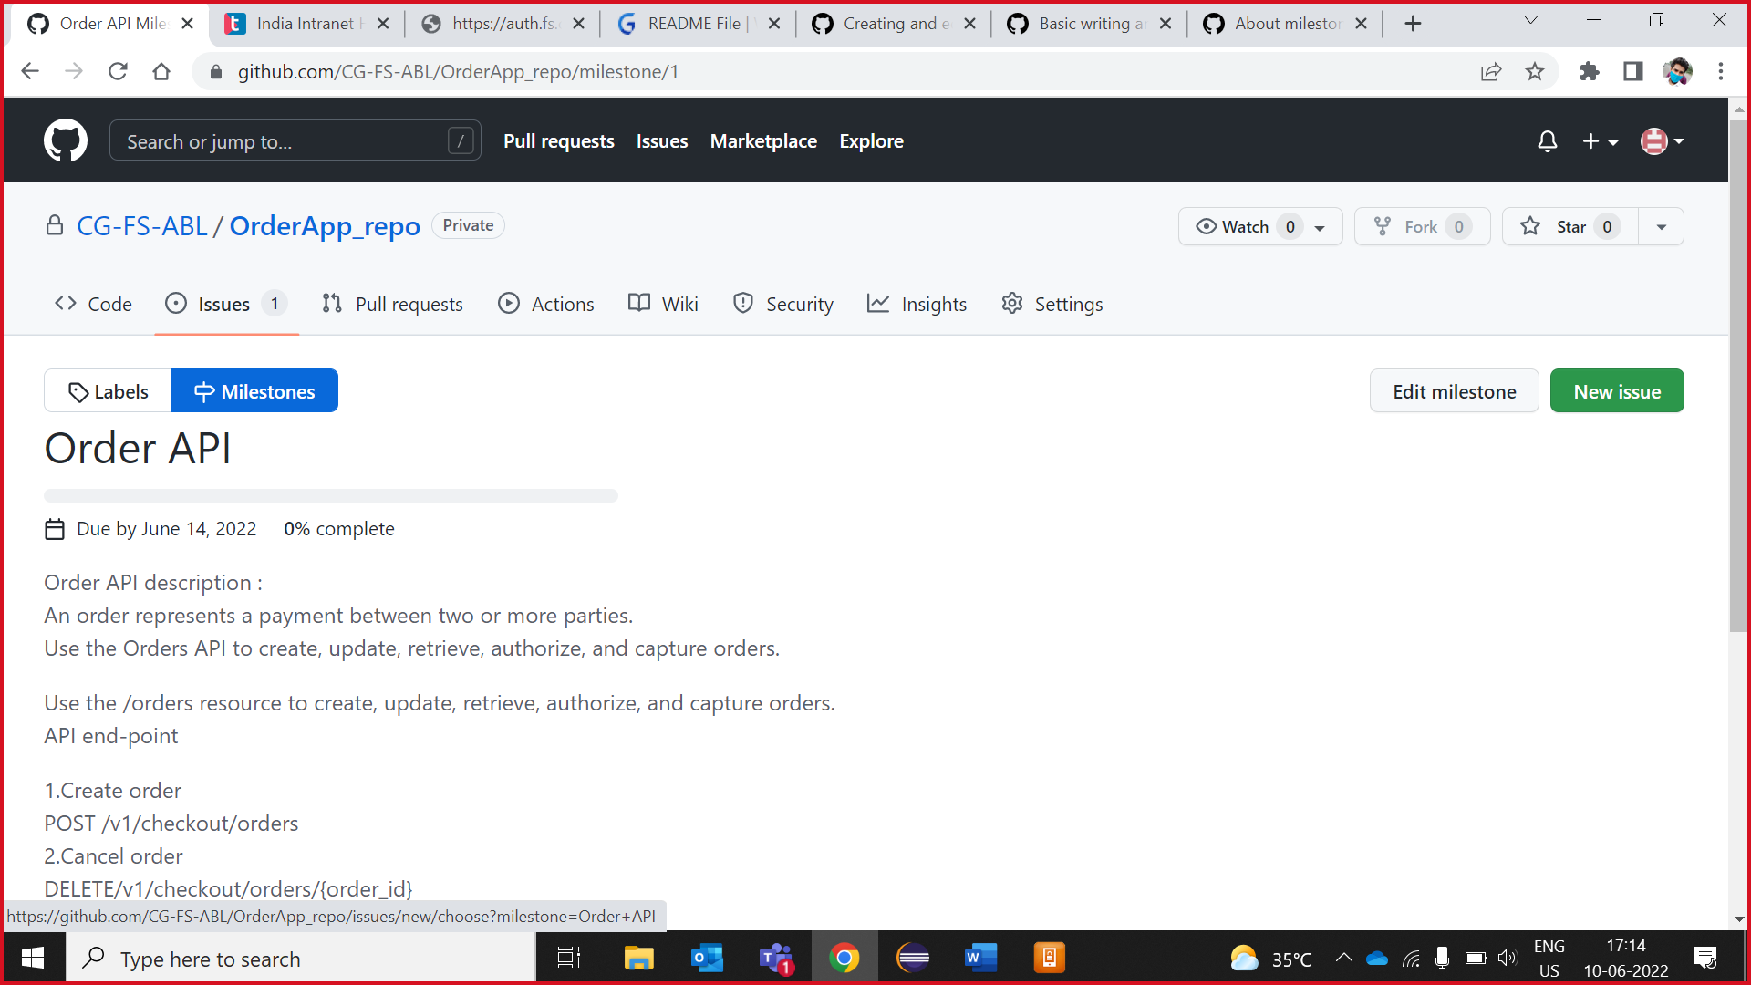

1. Type a title and description for your issue.

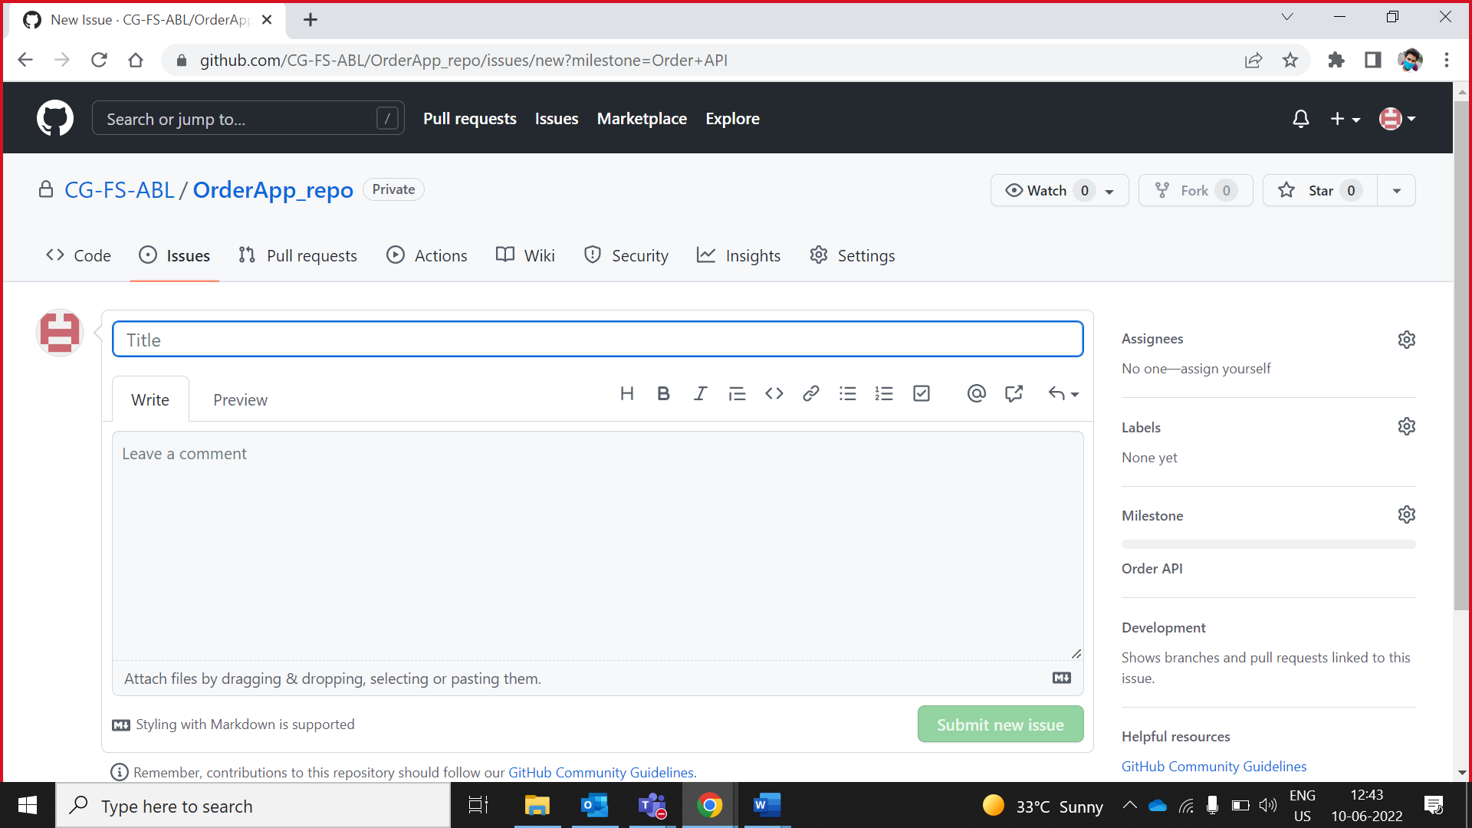

**Note: Issue must be associated with milestone.**

3.Issue added, Assign task to collaborator

Click on Assignees.

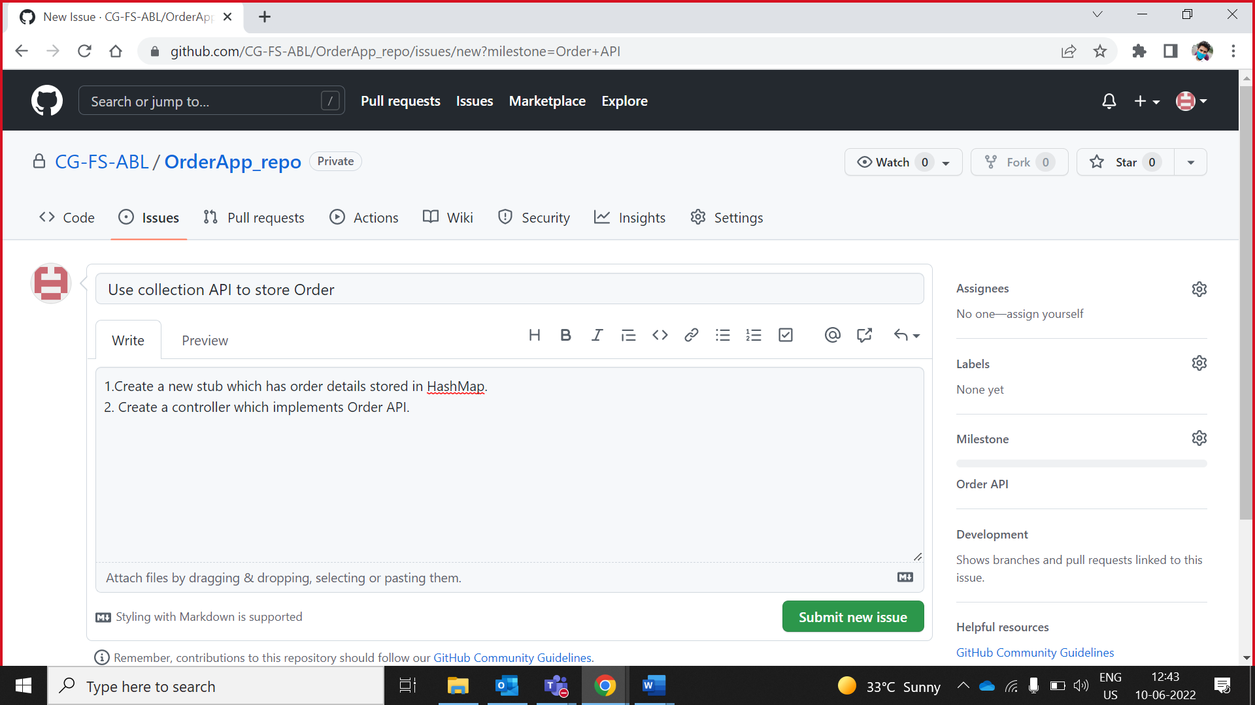

5.Select collaborator name from drop down

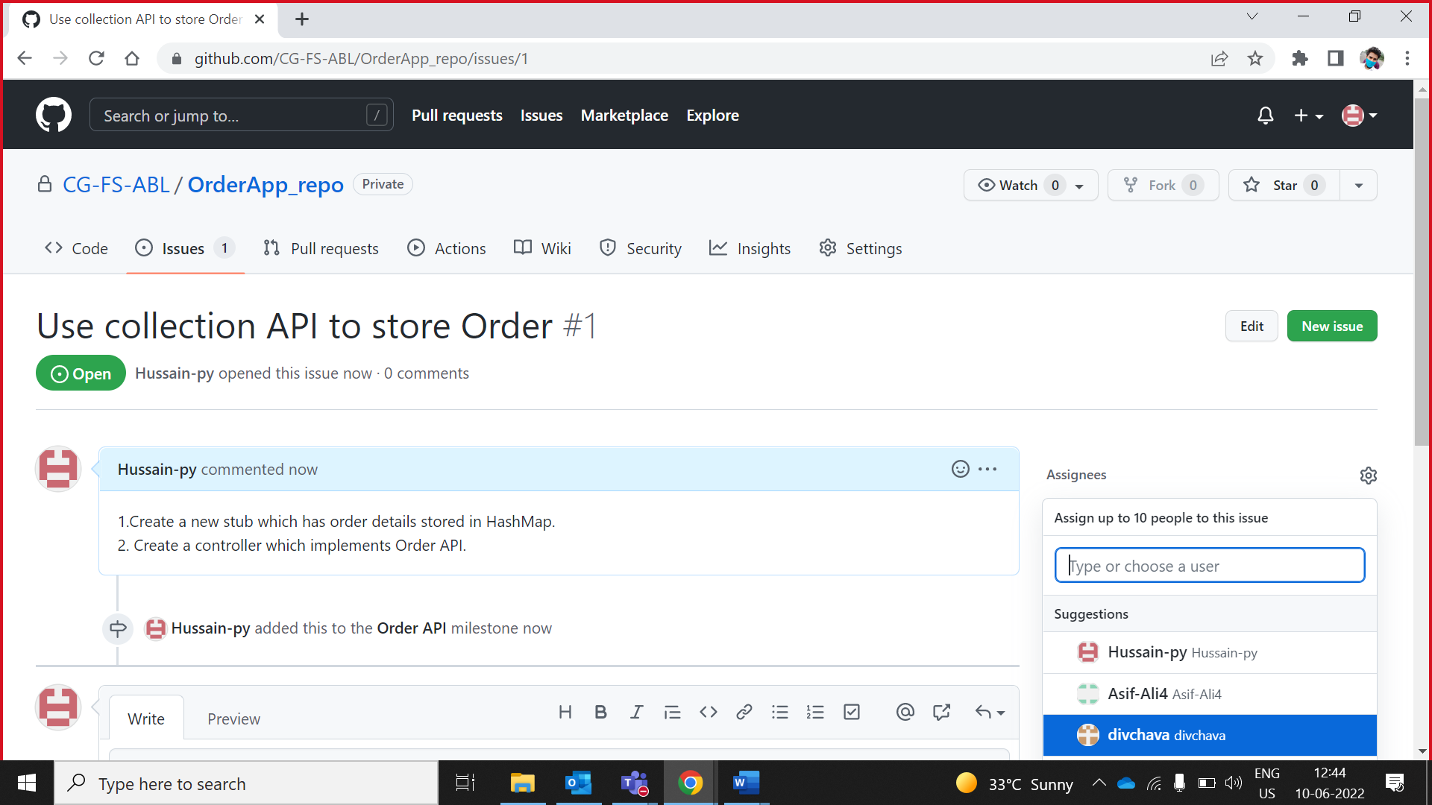

1. Issues Assignee to collaborator

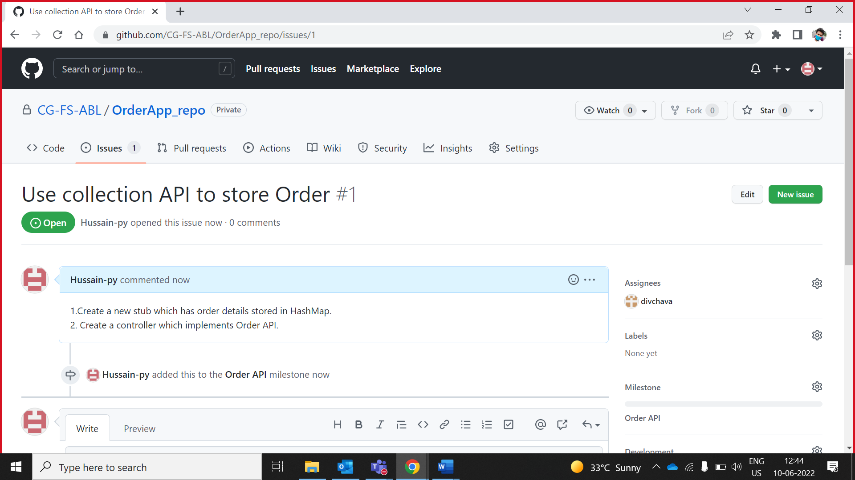

After assigning the task by Owner. Collaborator receives following e-mail

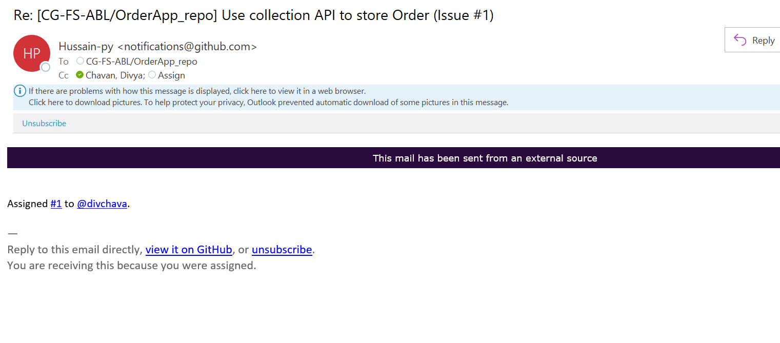

# **Owner clone GitHub repository in eclipse**

## **Clone Repository**

1. Copy repository URL.

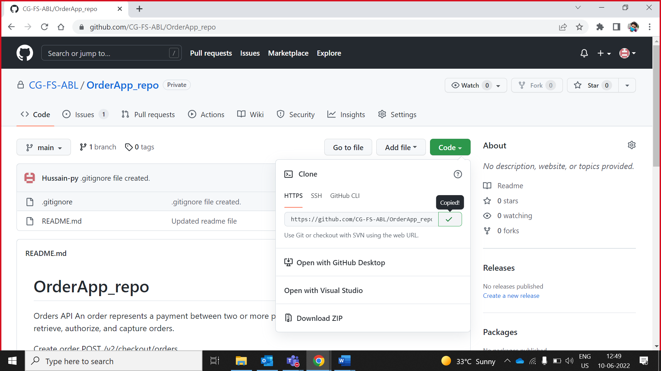

1. Go to eclipse and search **Git repositories**.

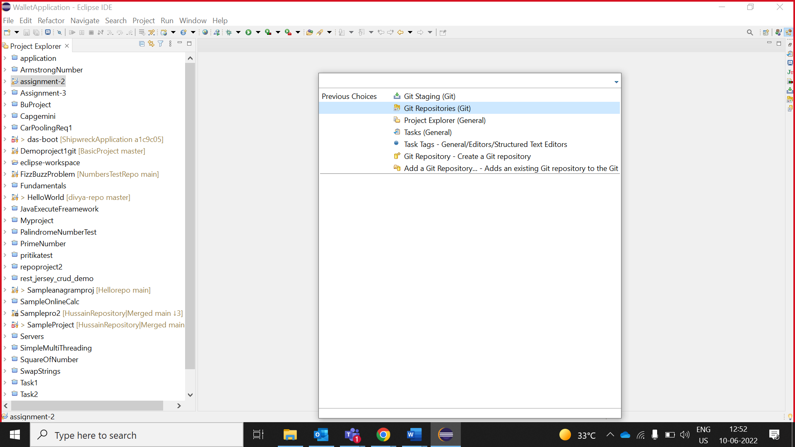

1. Right click on Git Repositories window and click on paste option.

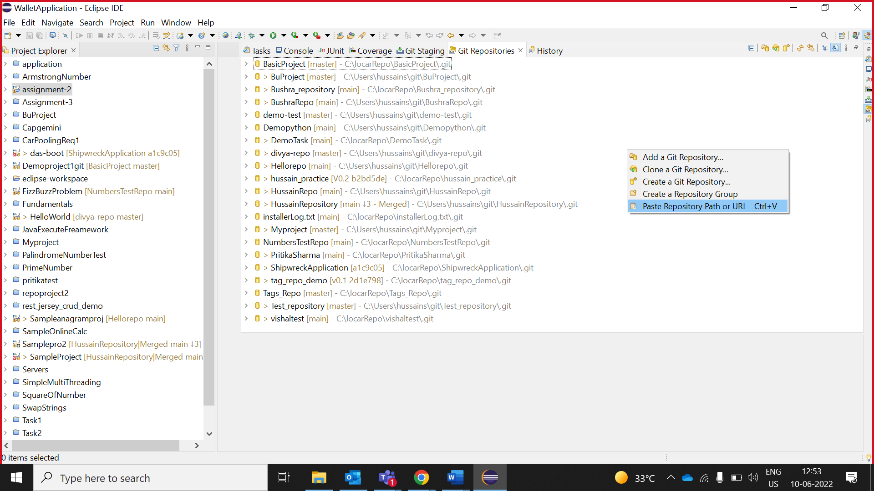

1. A window will pop up in which you have to paste **GitHub User-ID and Password (GitHub Token )** and click on the “**Next**” button.

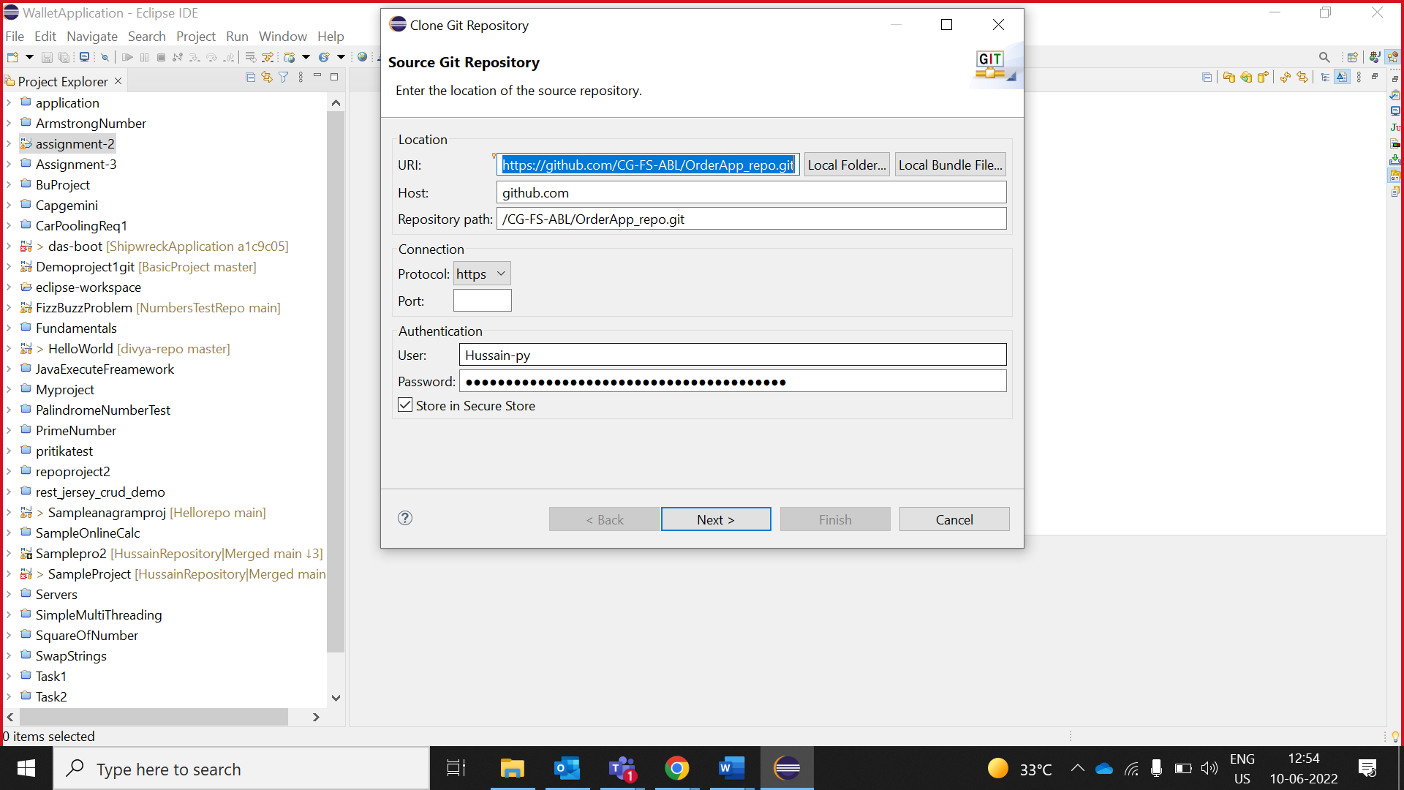

1. Select “**Branch**” and click “**Next** “.

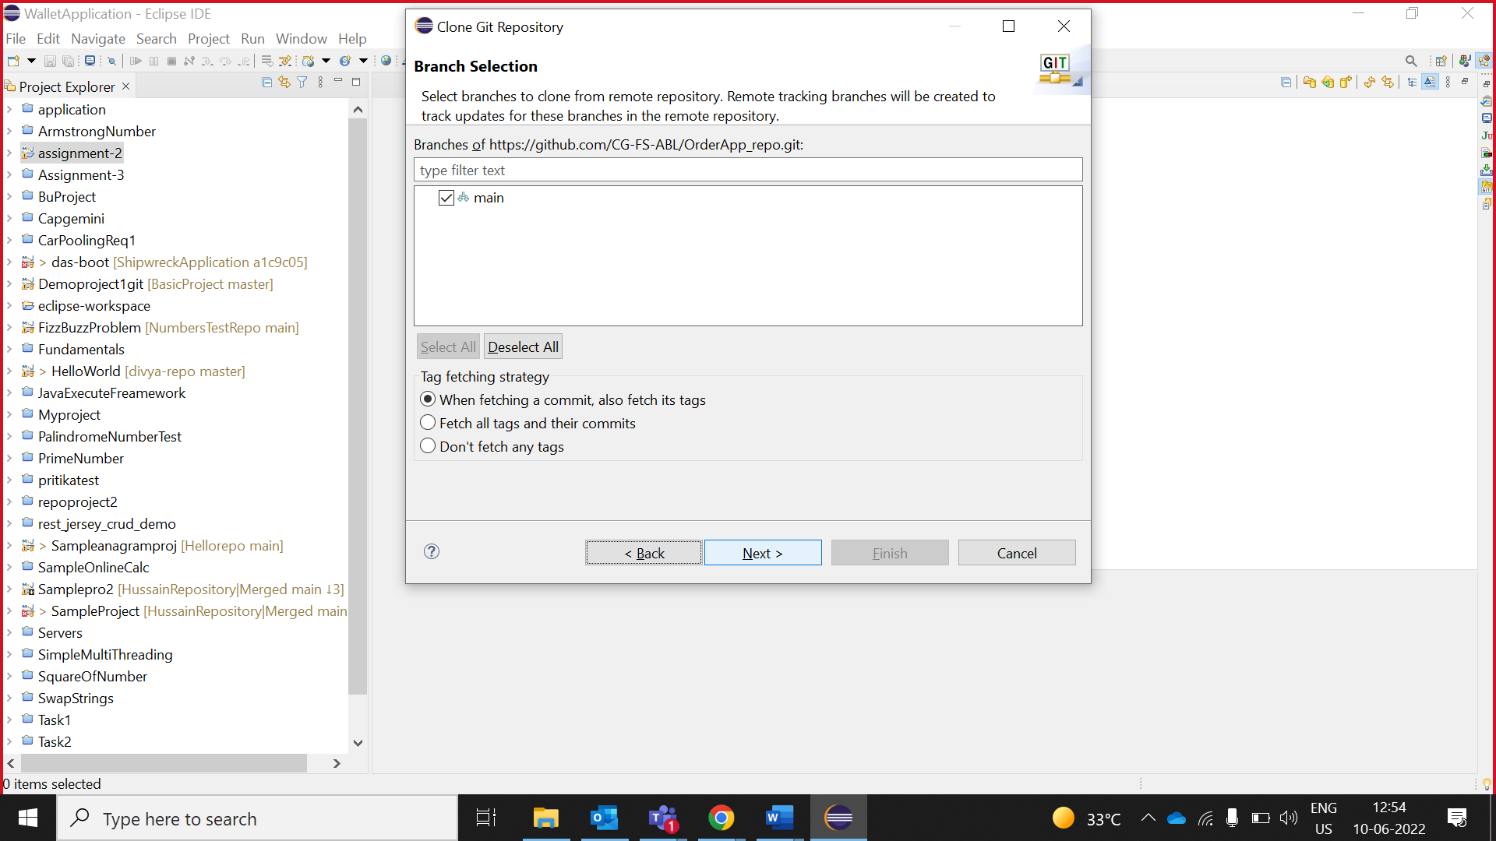

1. Select the **Folder directory** in which you want to clone the repository and click “**Finish**“.

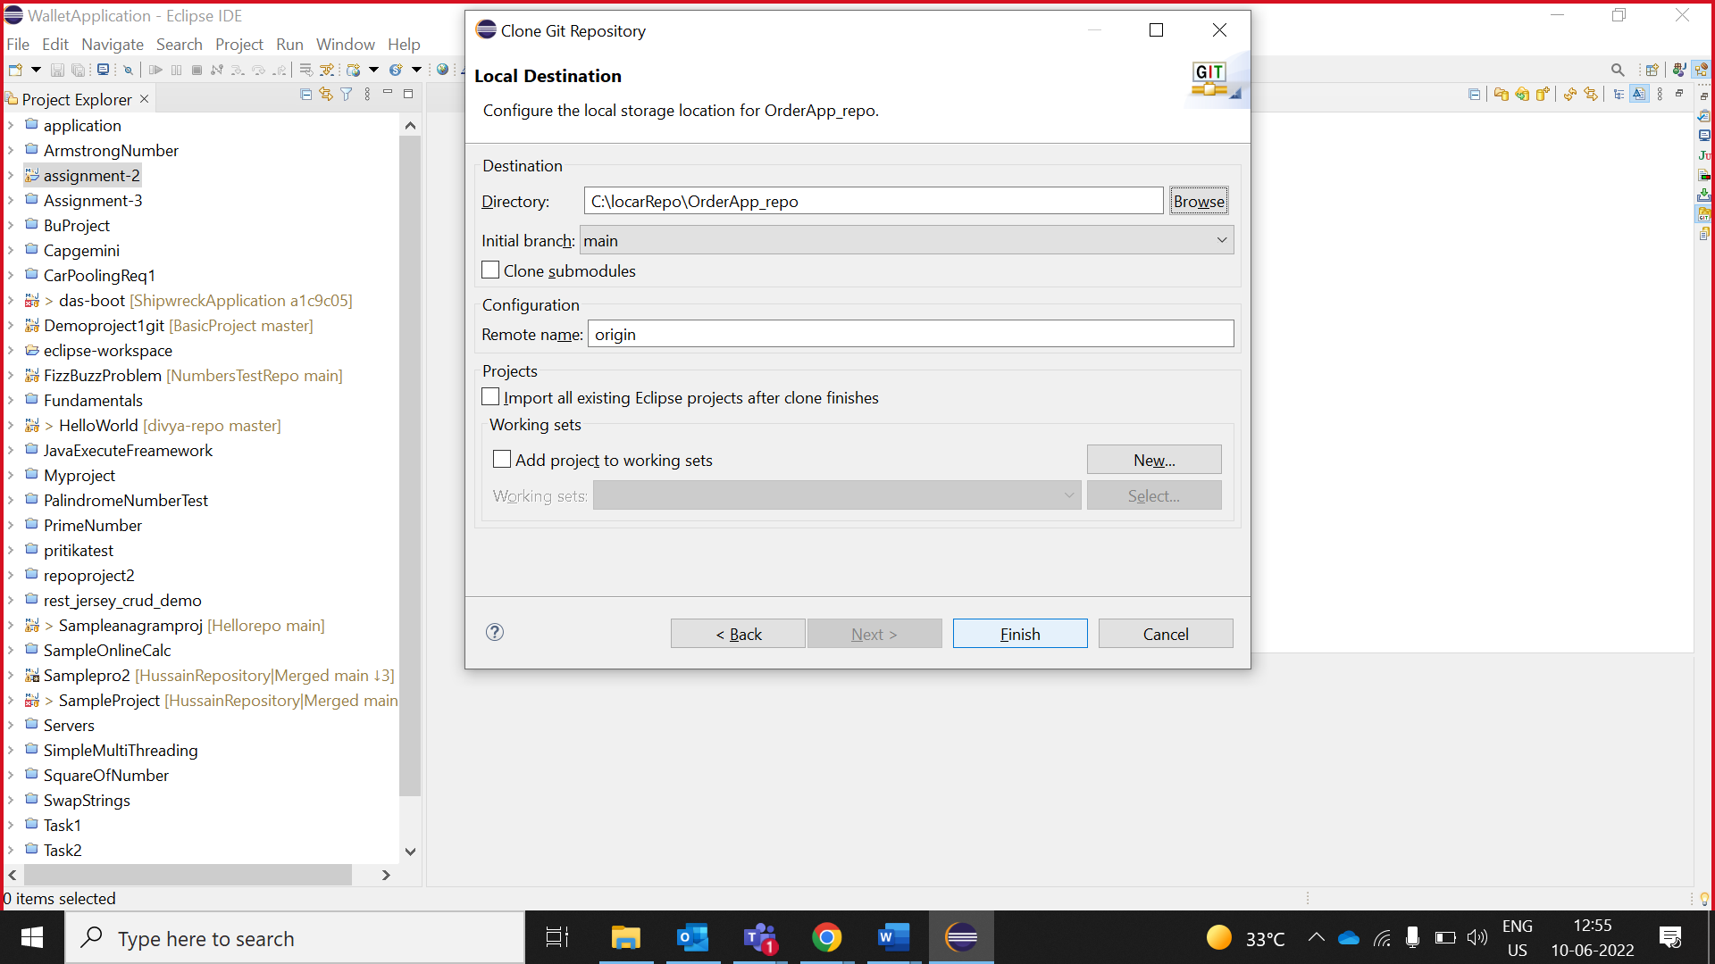

**We have successfully cloned the GitHub Repository**

## **Create maven project**

1. Expand the clone repository folder and right click on “**Working Tree”** and select **“Copy Path”** option.

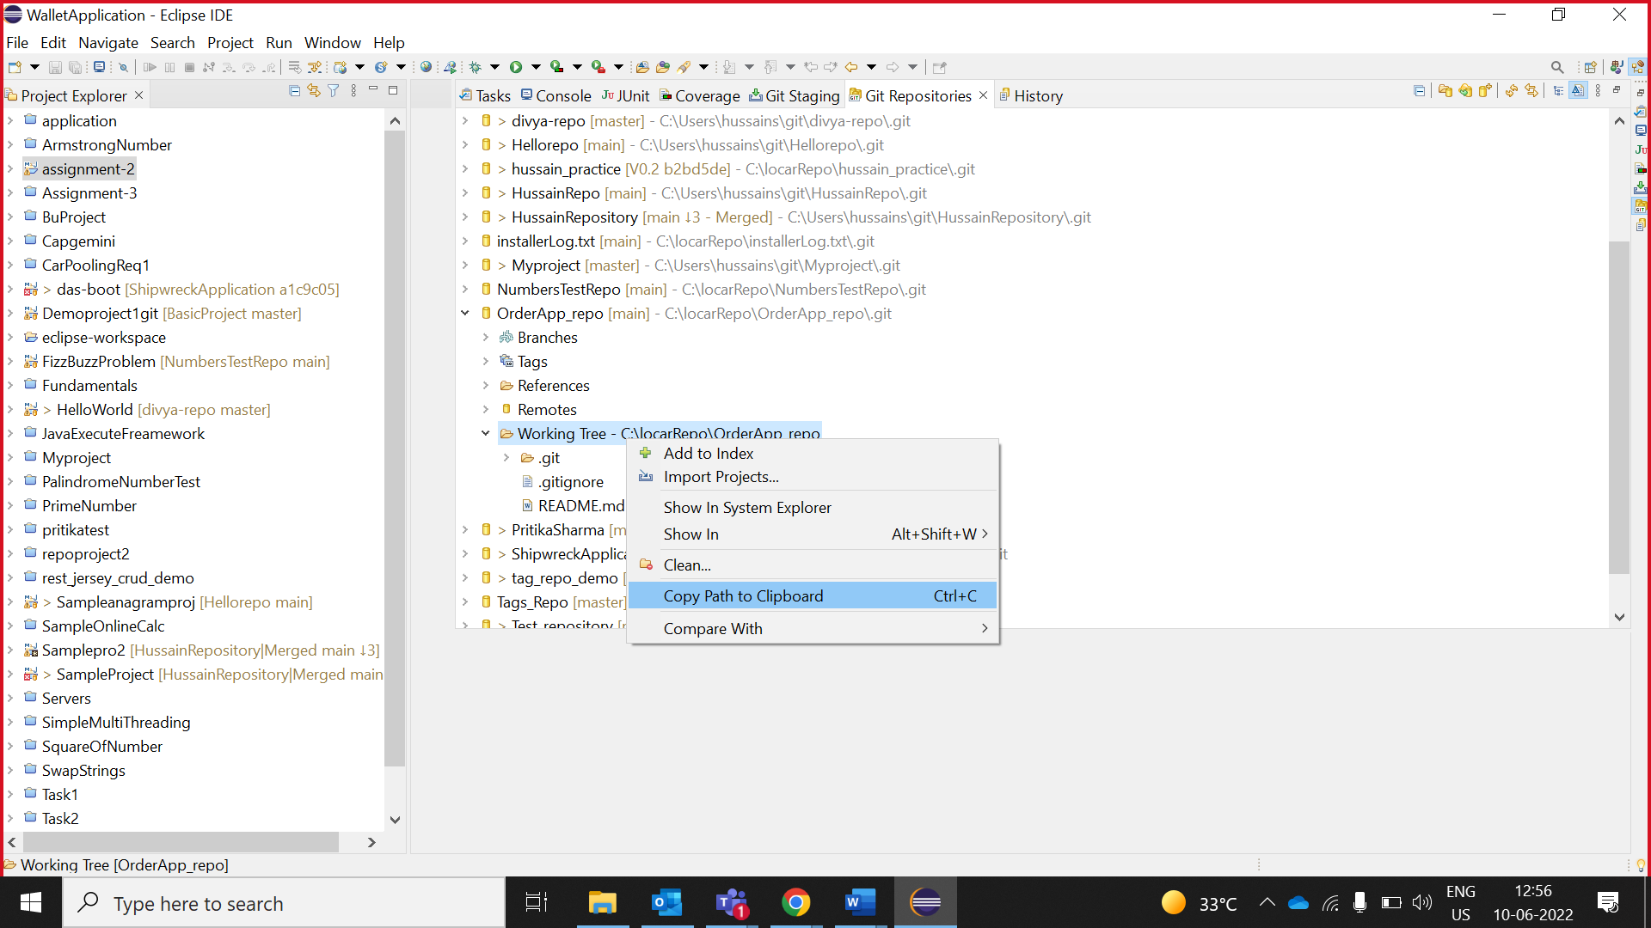

1. From the **File** menu, choose **New**, and then choose **Maven Project.**

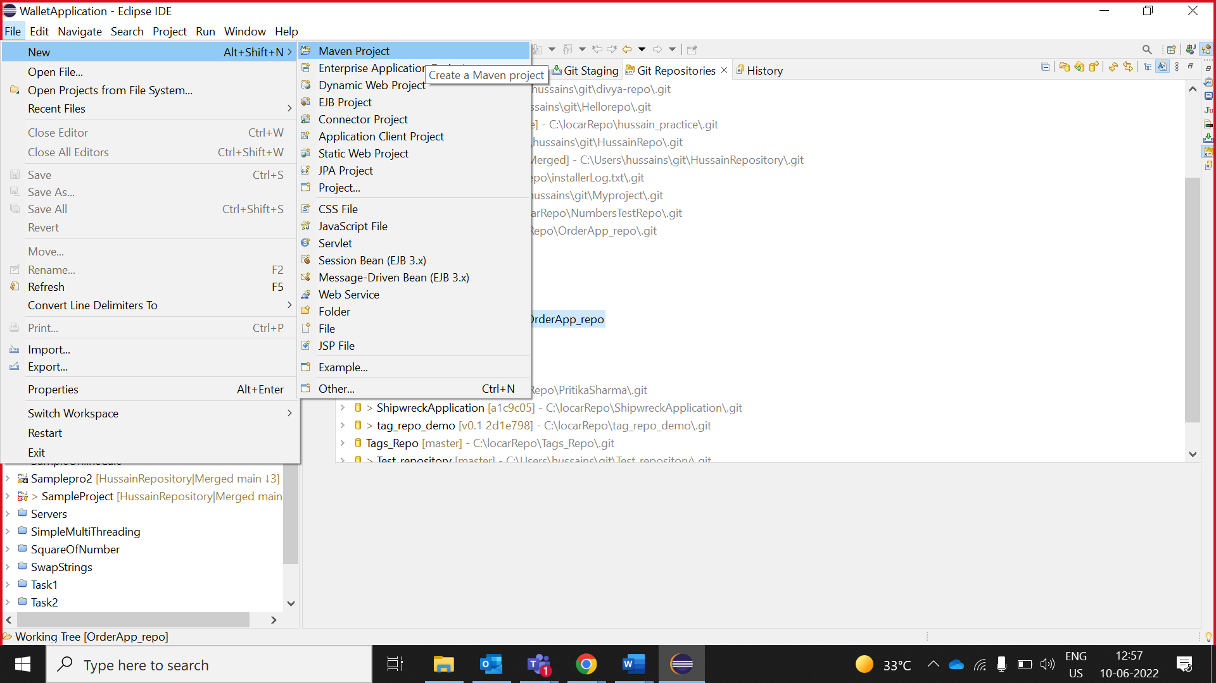

1. The **New Maven project** wizard opens.

Uncheck “**Use default Workspace location** “and paste Working Tree path which you have copied in step 1 and click **Next**.

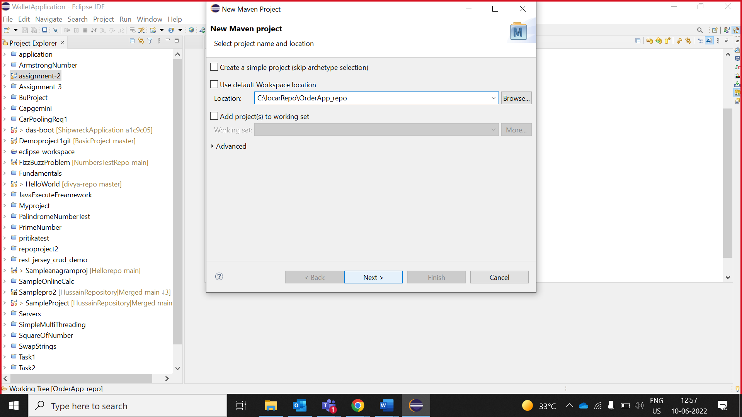

1. Select the *archetype,* ‘*maven-archetype-quickstart*' and *click* on ***Next.***

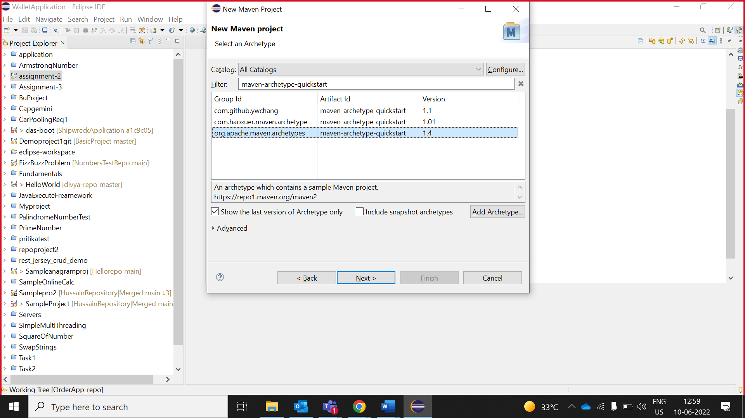

1. Specify the ***Group Id*** & ***Artifact Id*** and *click* on ***Finish.***

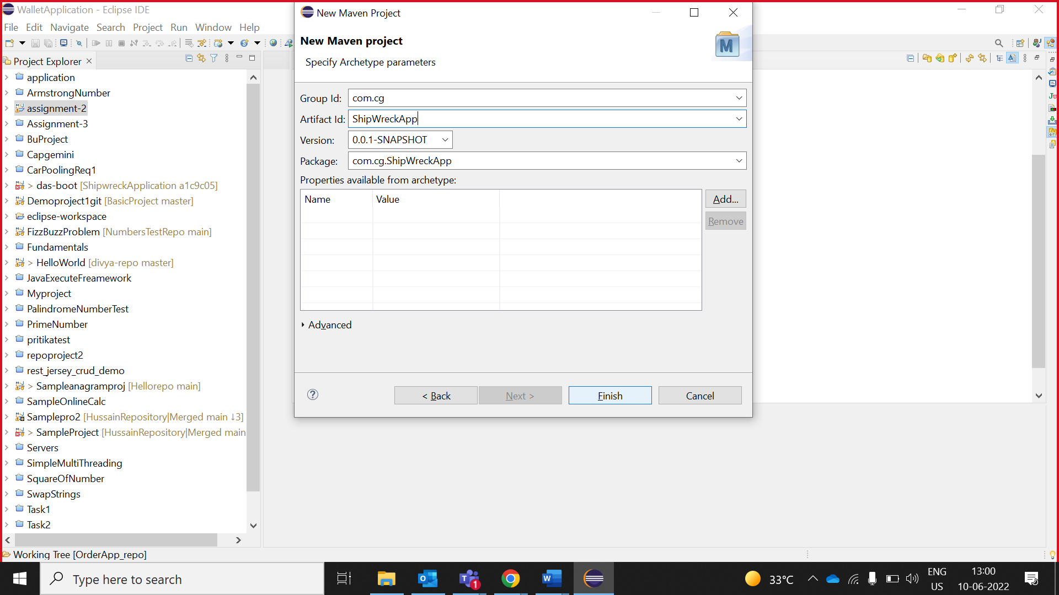

**Note*:*** Here the ‘artifact Id‘ is your project name.

1. Create your Project structure and write method stubs and add **//TODO’s**.

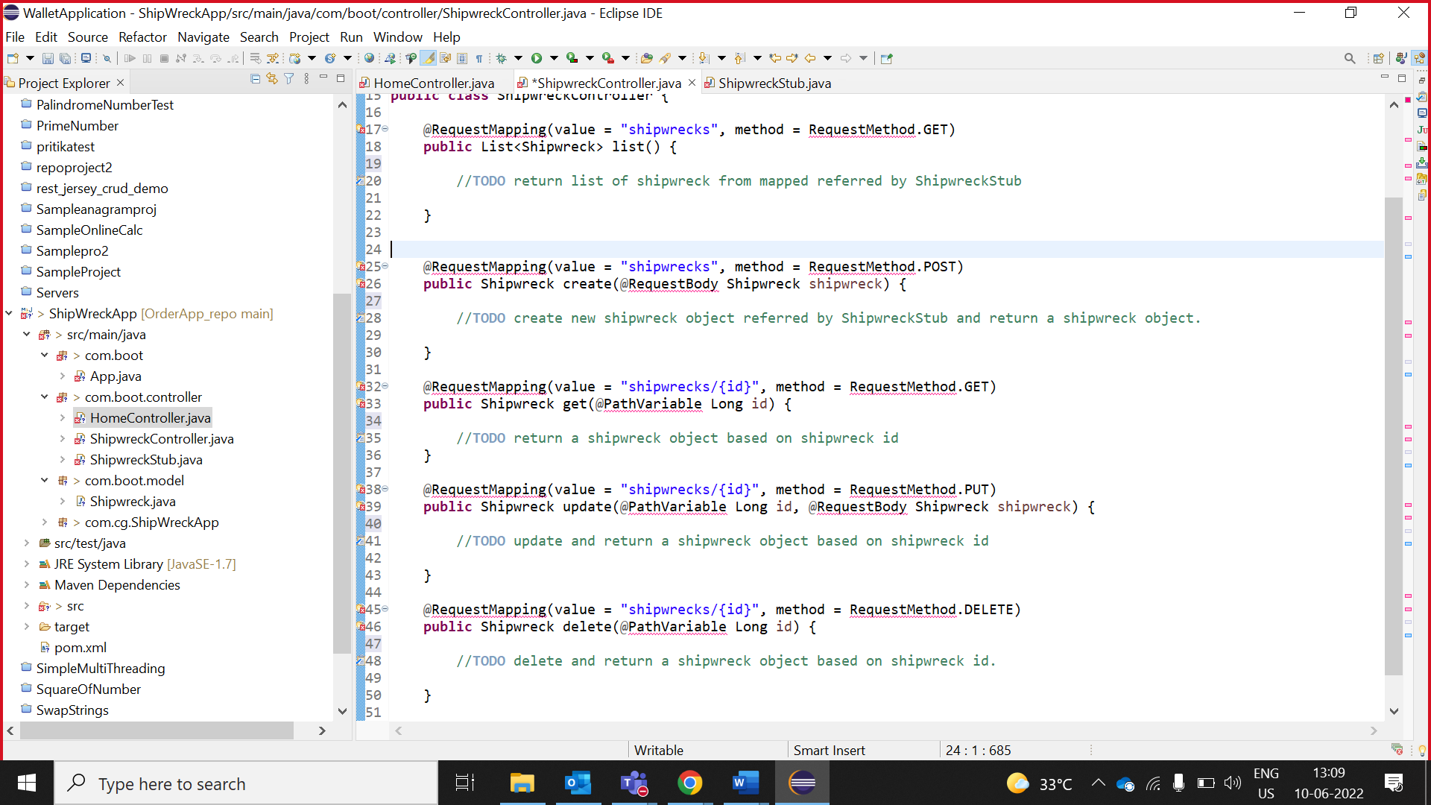

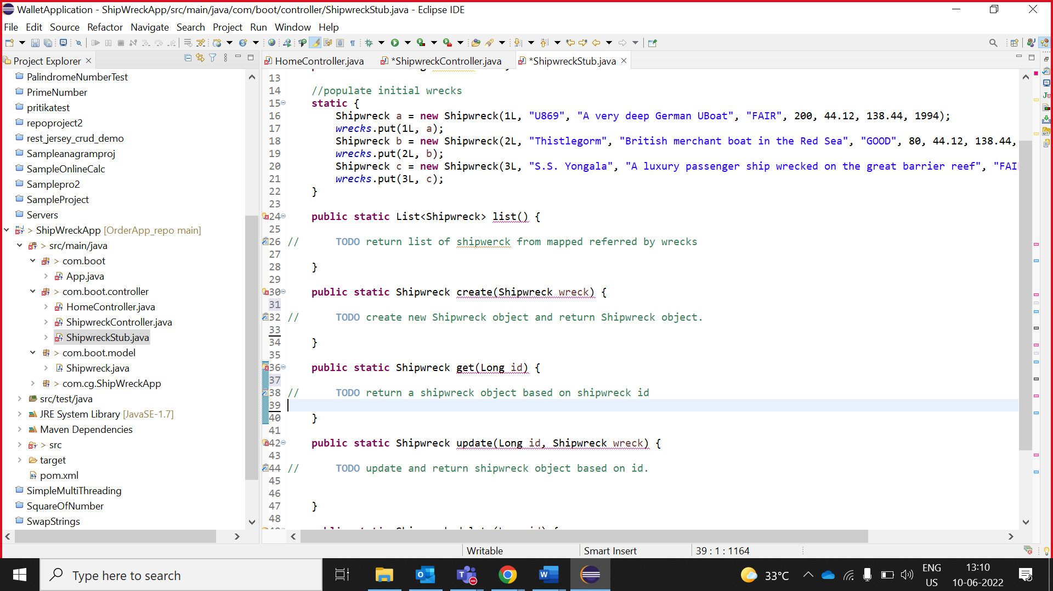

**Note**: Write parameterized test cases.

1. Click on the search symbol on right top and In the filter text box enter Tasks, Under **General**, select Tasks.

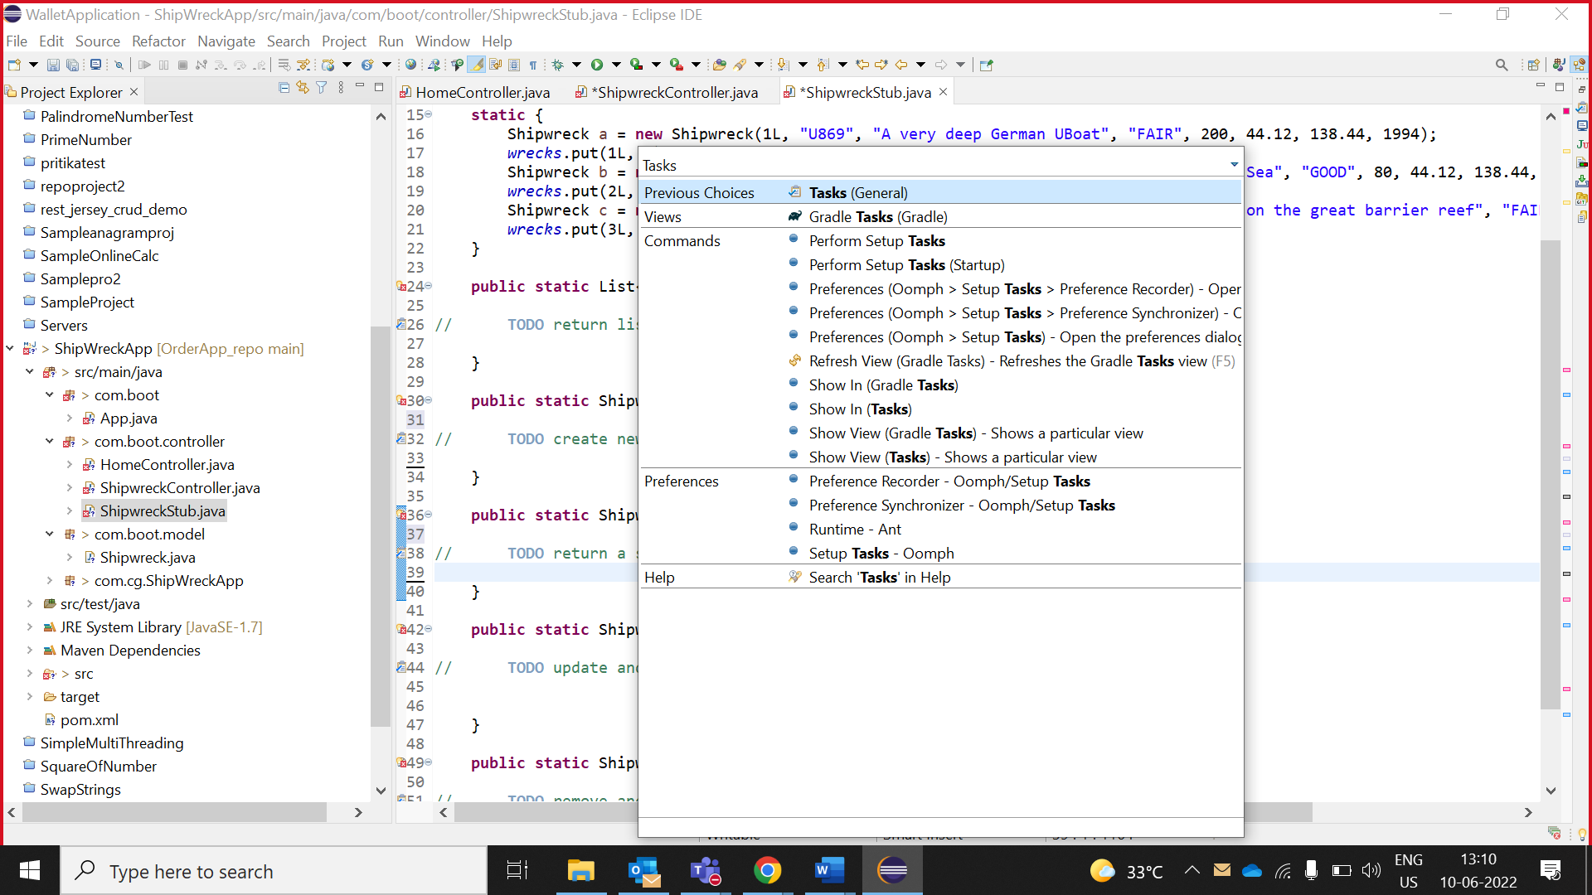

1. The Tasks view can be used to view all the tasks.

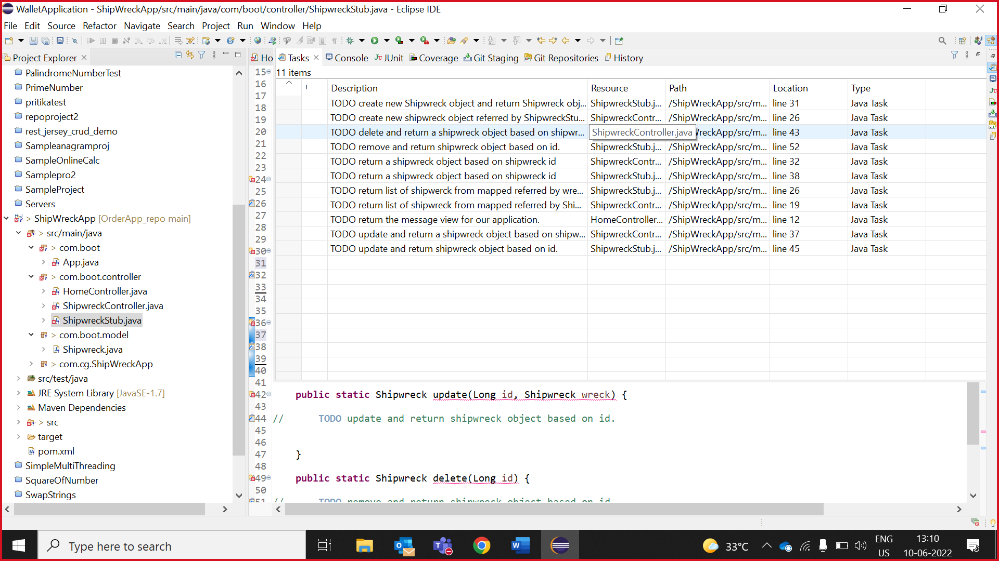

## **Push Project to GitHub**

1. In **git stagging**.

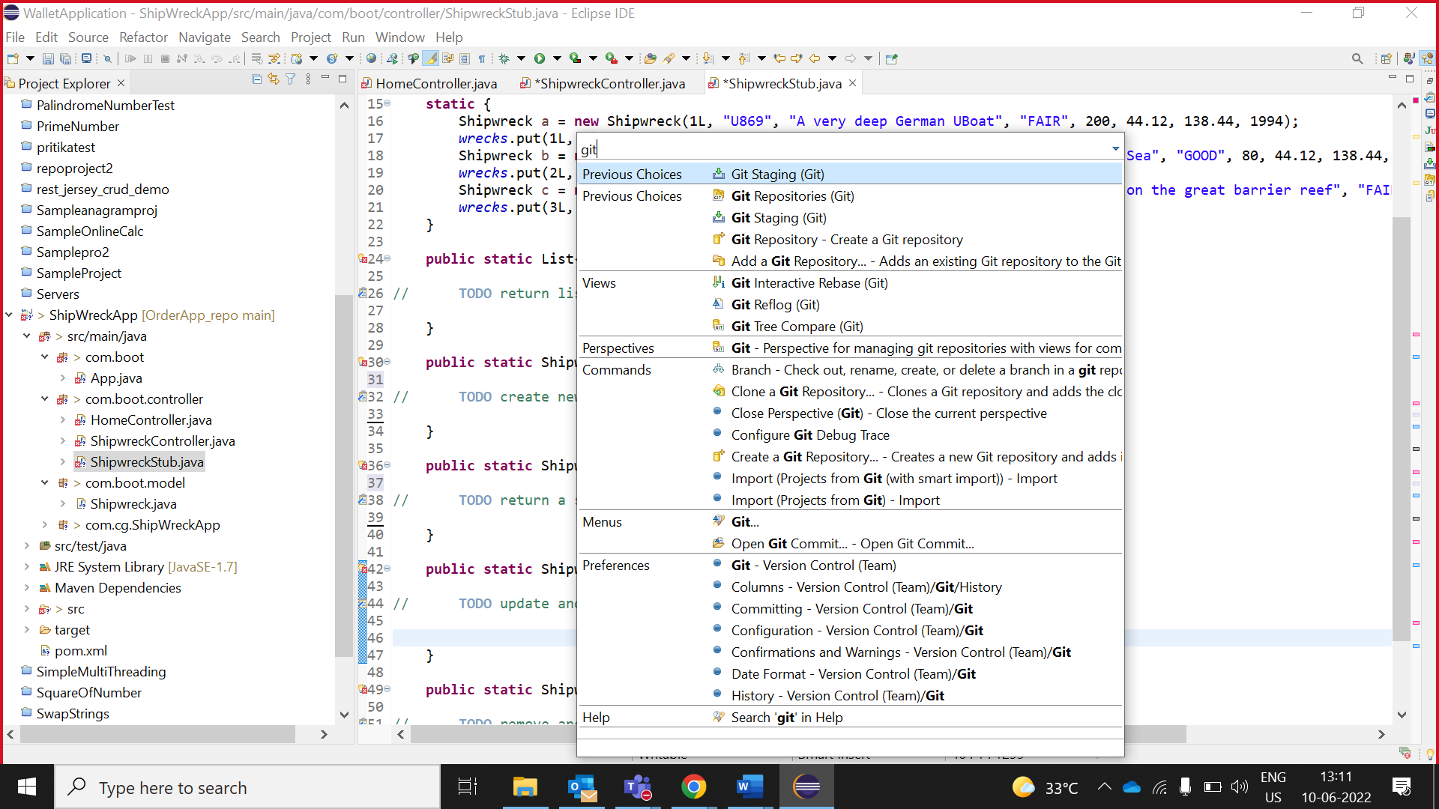

1. **Write commit message and click “Commit and Push”**

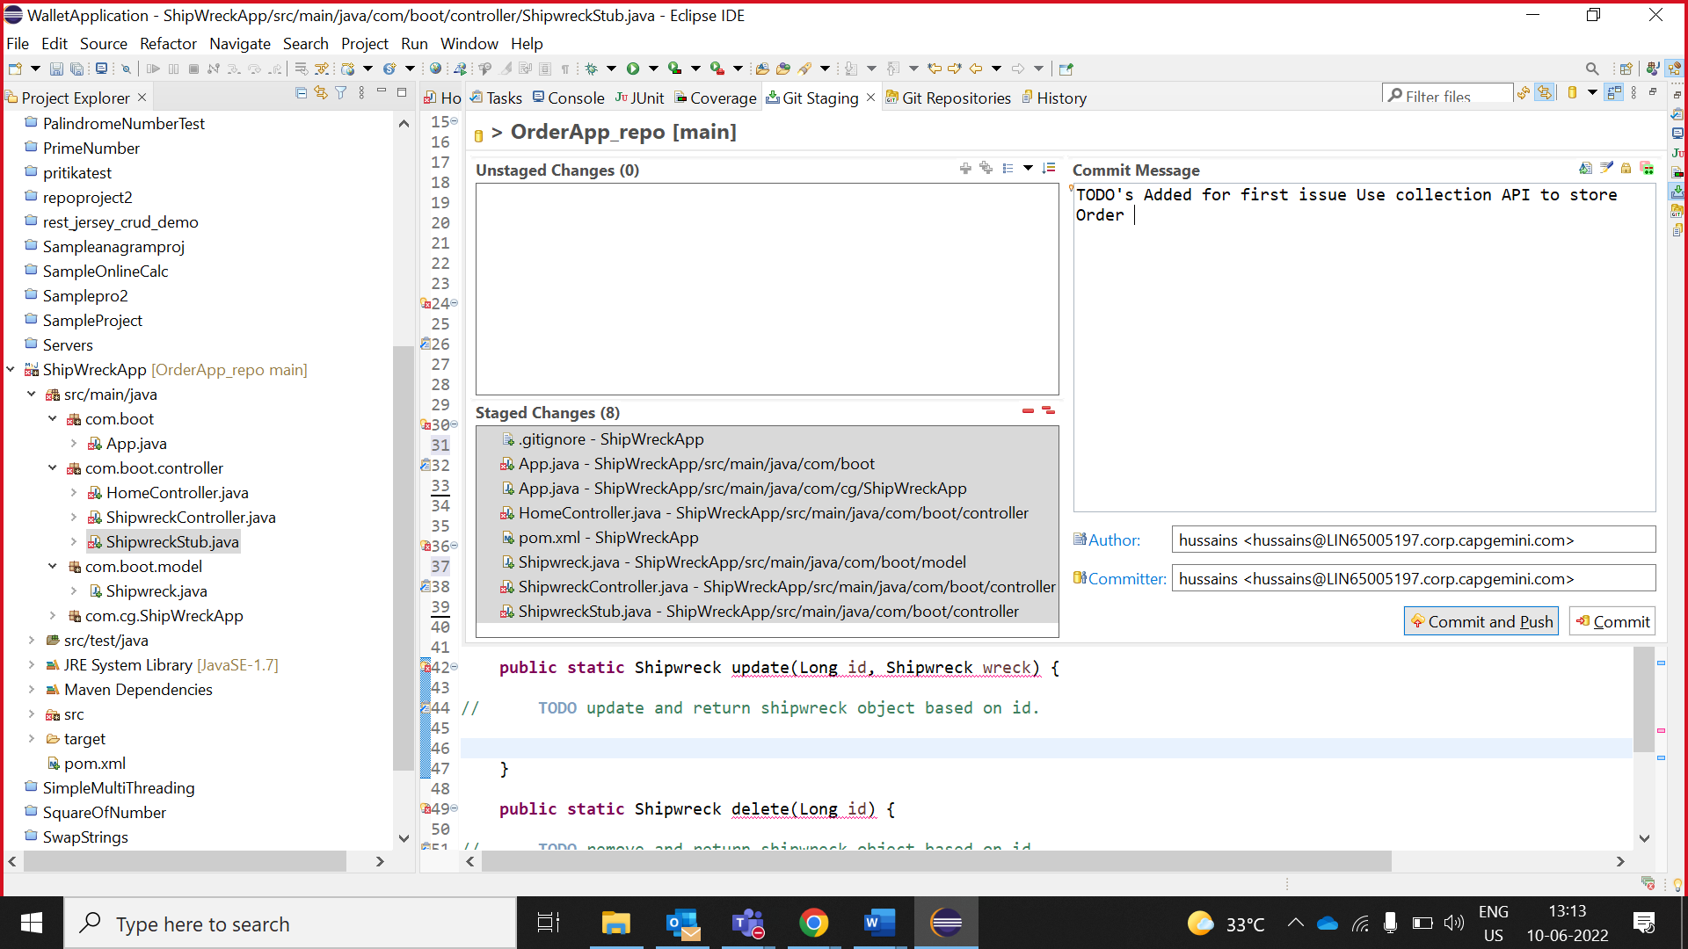

1. Click **Close**

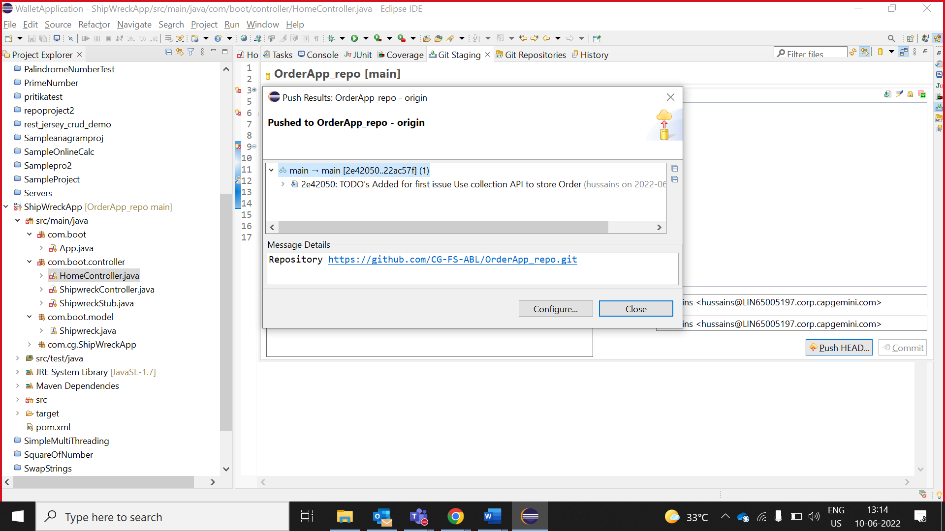

## **Create Tag**

1. Go to **git Repositories**.

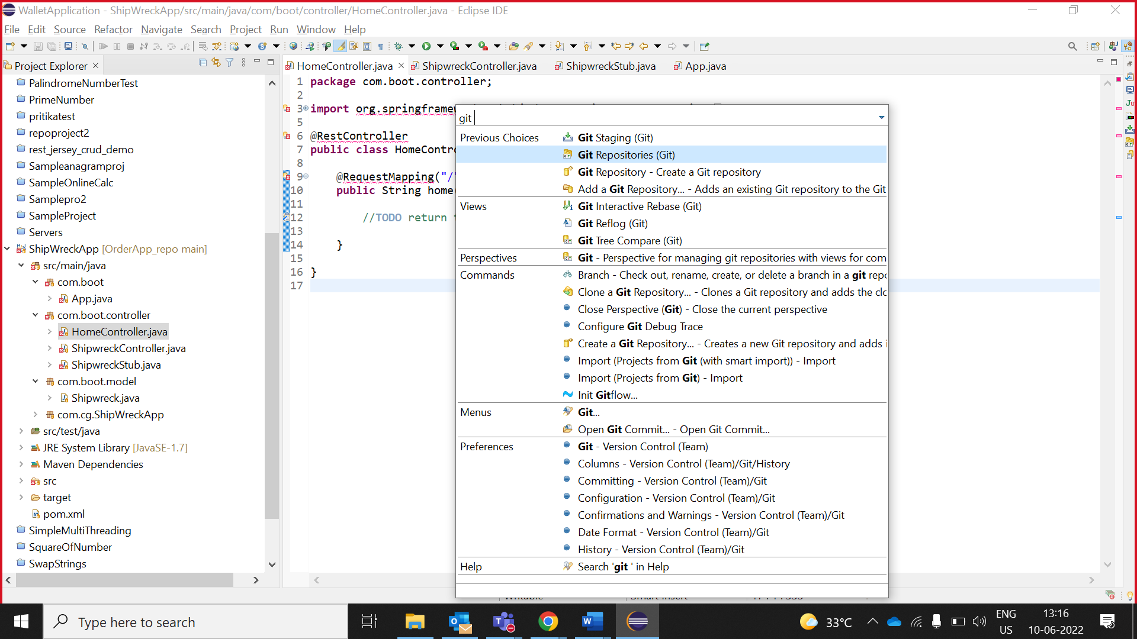

1. In the project tree, right click on **Tags** à **Create Tag**

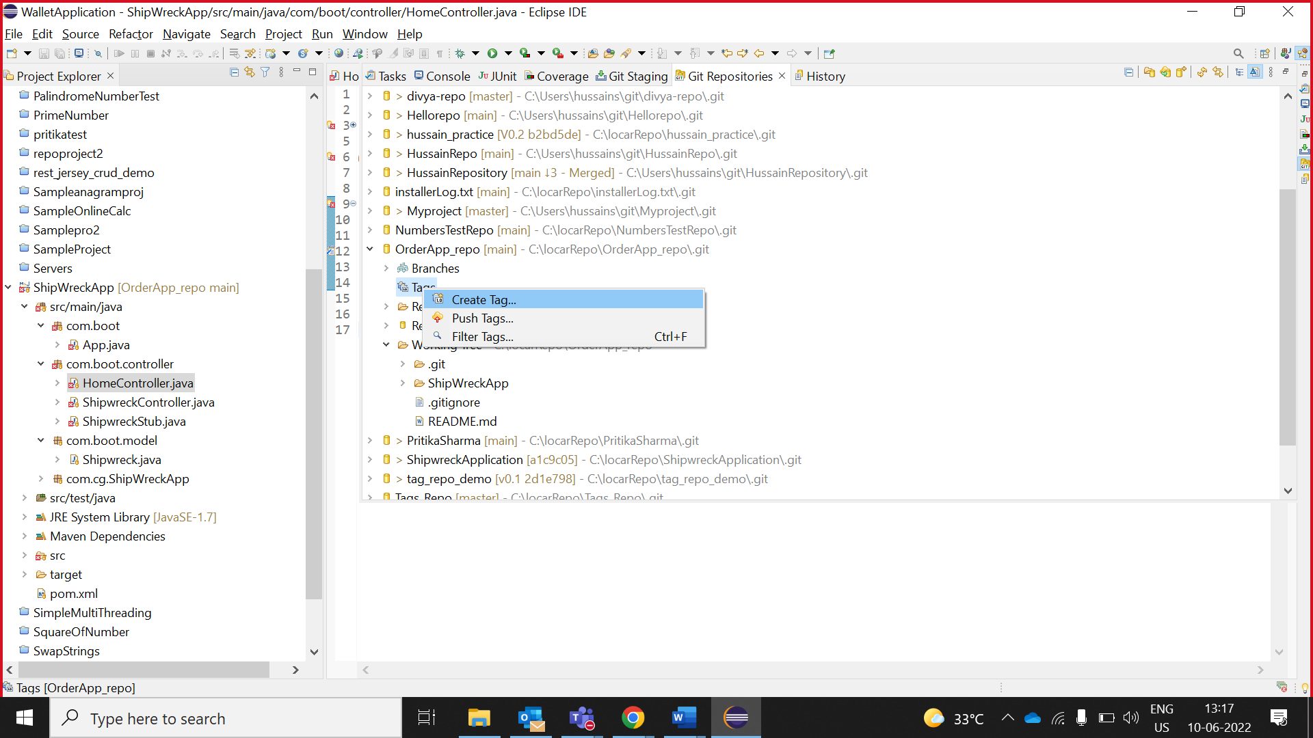

1. Enter tag name and tag message.

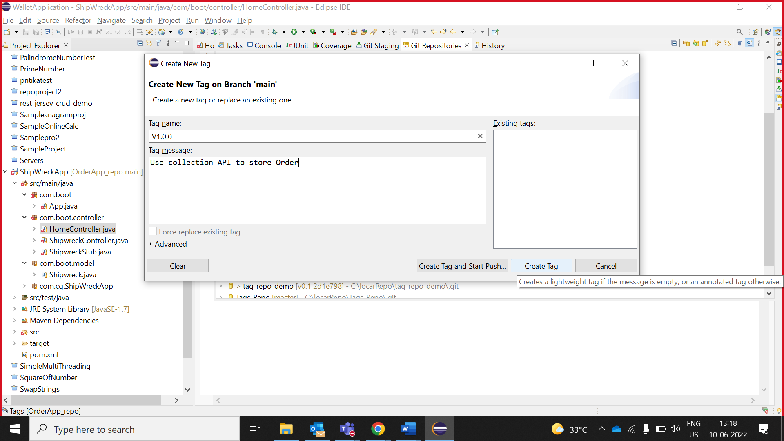

1. right click on tag V1.0.0 à **Push Tag**

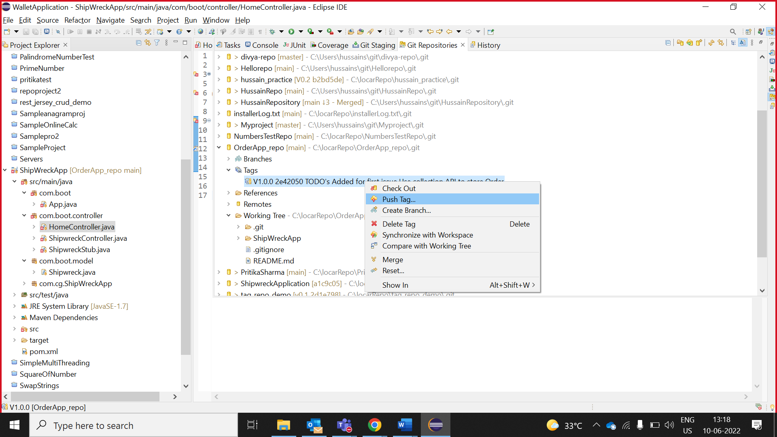

**Note**: After creating the tag V1.0.0 for instance, you need to Push the tag to the repository

1. Click **Preview.**

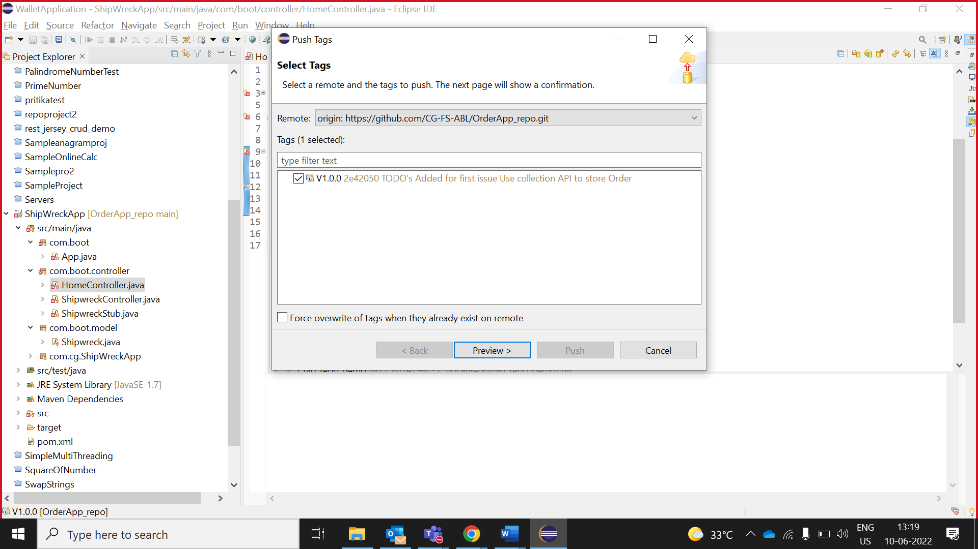

1. Click **Push**

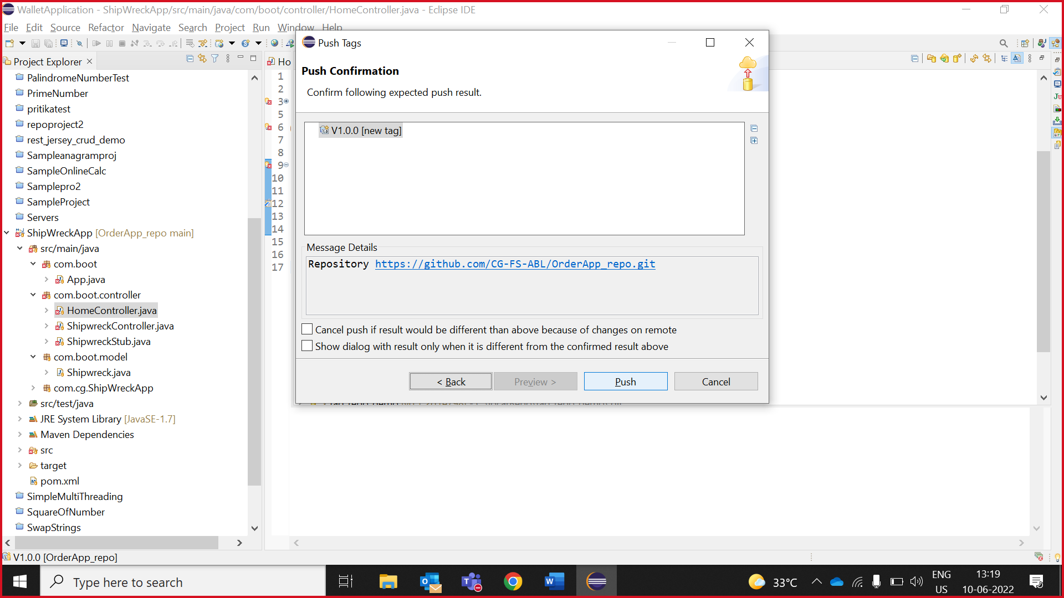

1. Click **Close.**

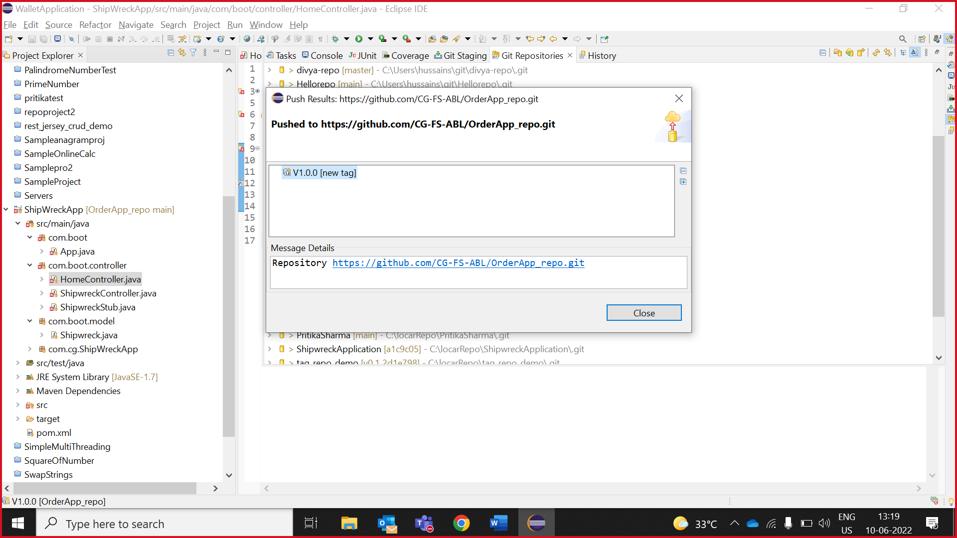

# **Collaborator clone GitHub repository in eclipse**

## **Collaborator invitation**

1. Collaborator received invite after assigned the issue by owner.

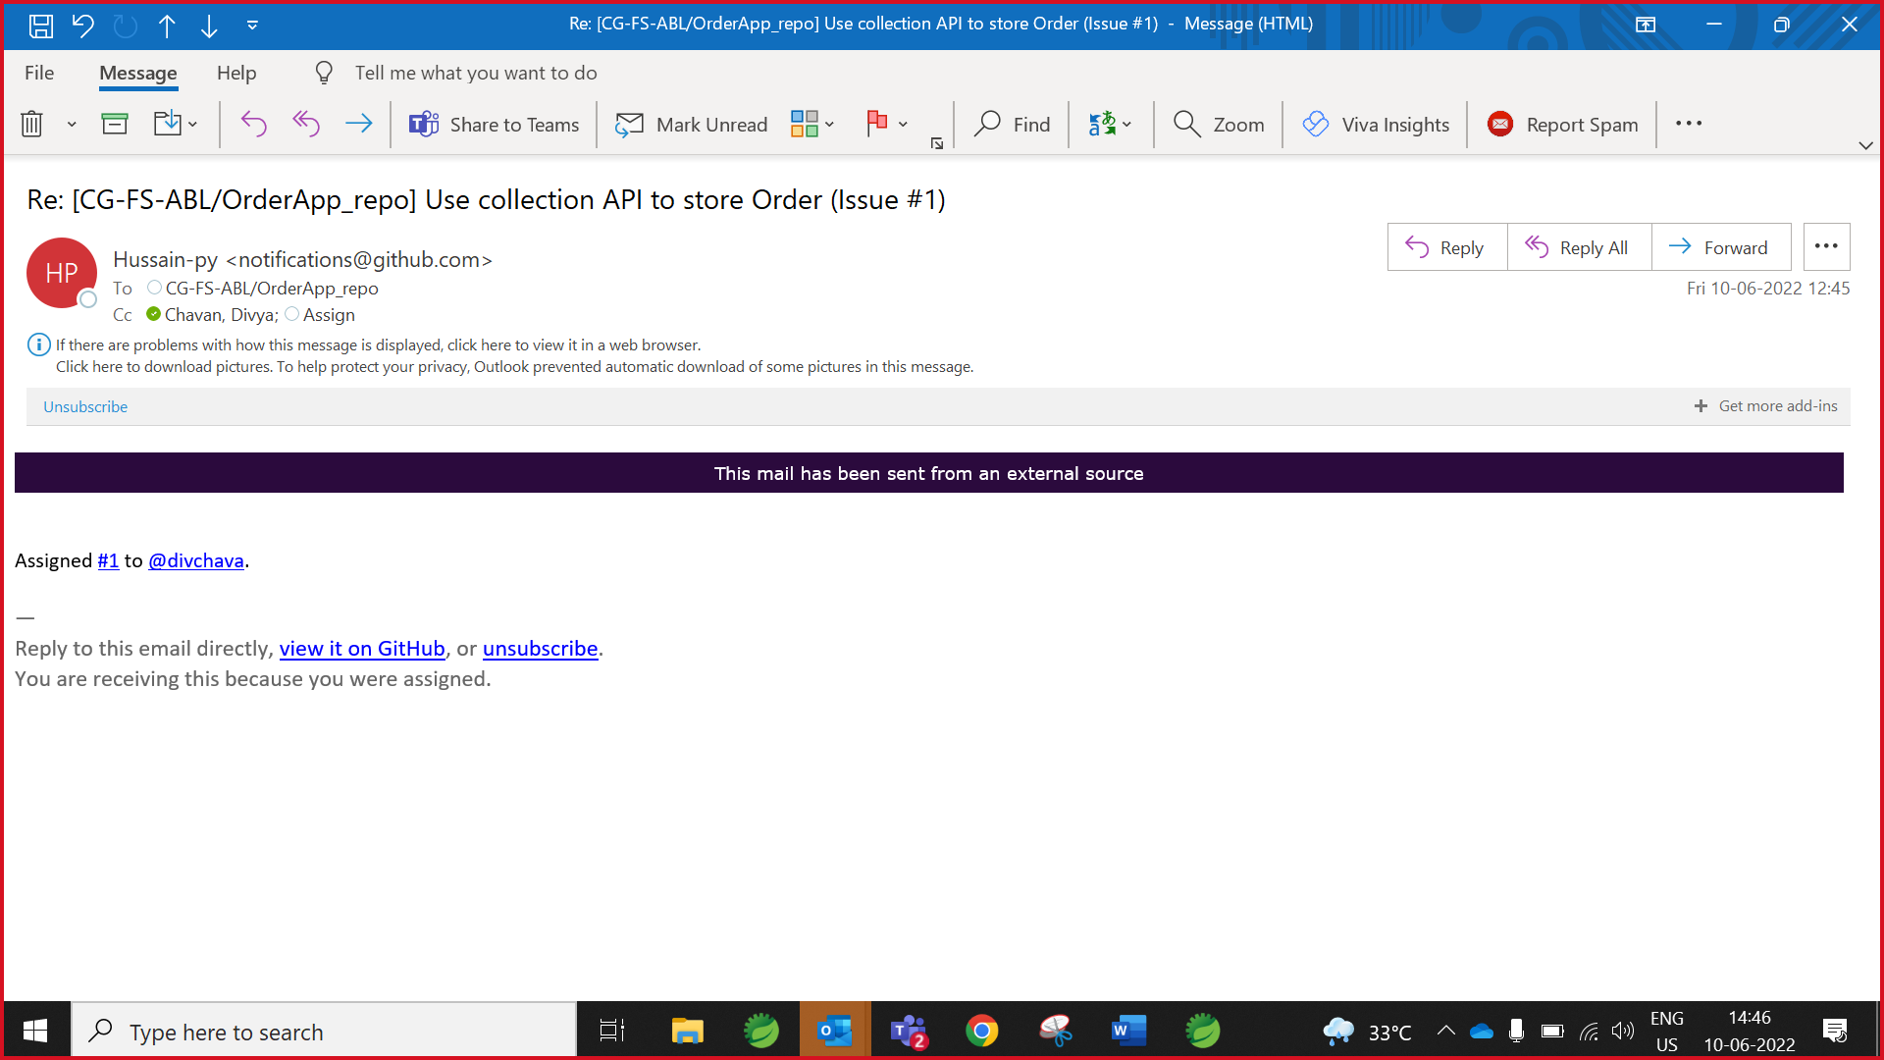

## **Collaborator Clone Repository.**

1. Copy repository URL.

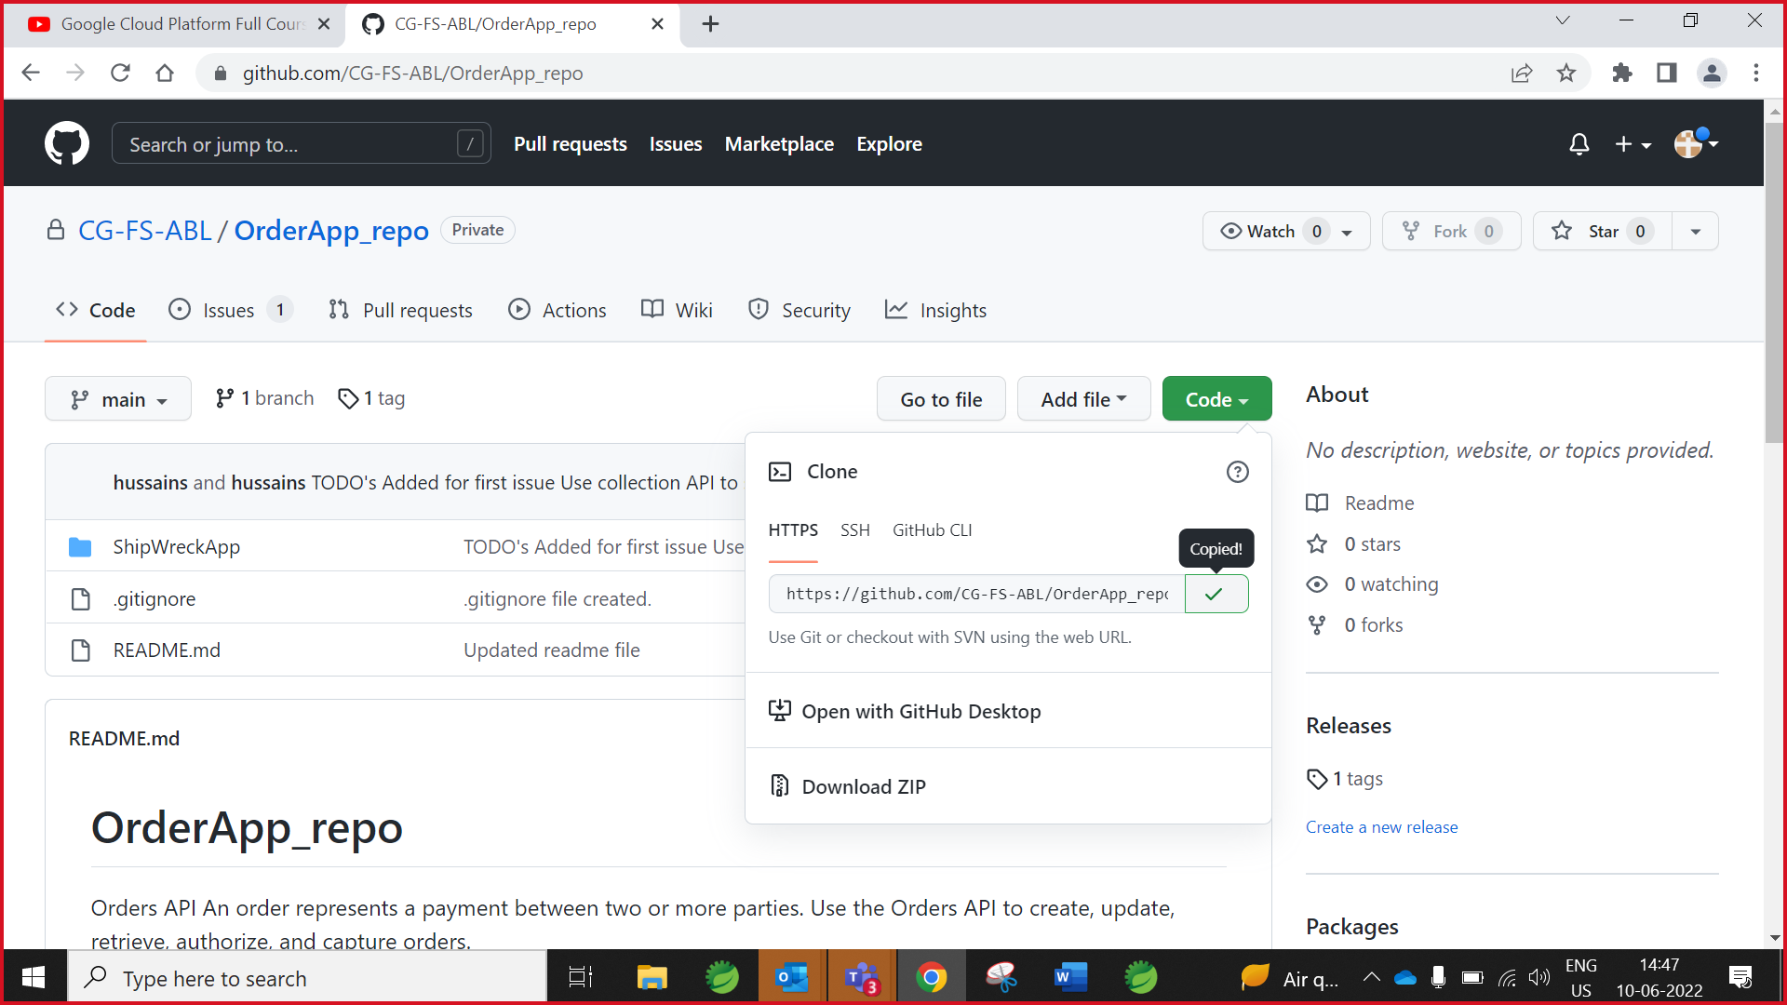

1. Go to Git repositories and right click on Git Repositories window and click on paste option.

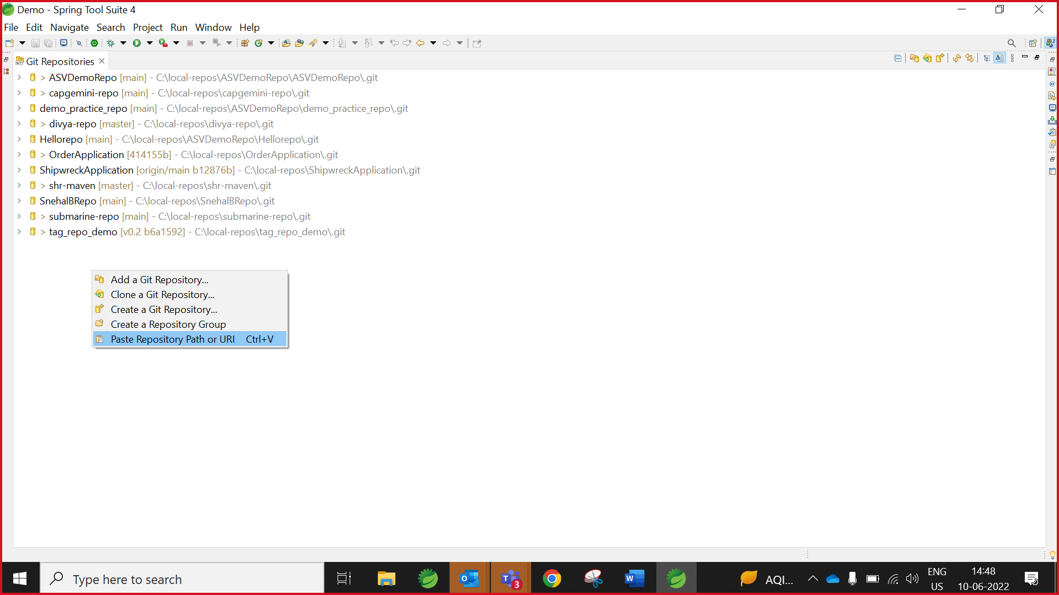

1. A window will pop up in which you have to paste GitHub **User** ID and **Password (GitHub Token)** and click on the “Next” button.

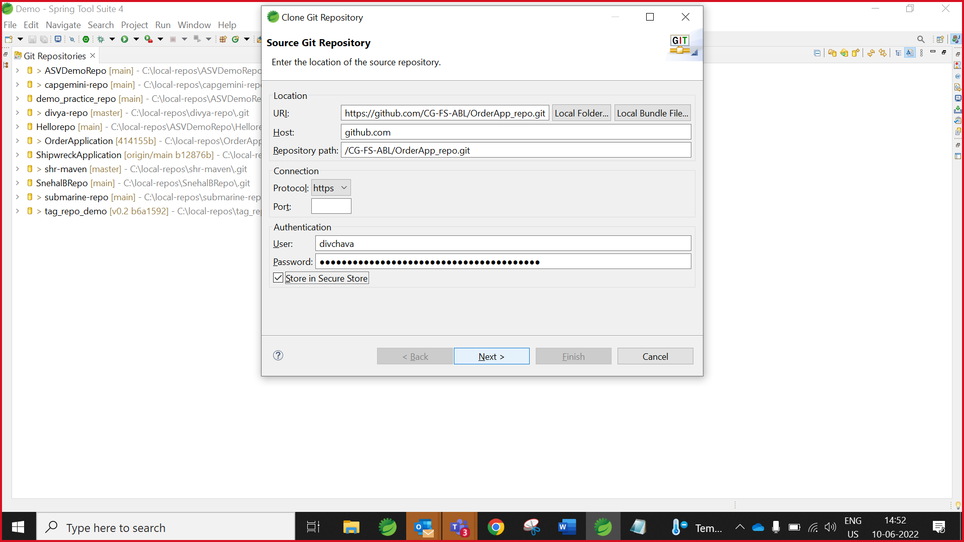

1. Select the Folder directory in which you want to clone the repository and click “Finish”.

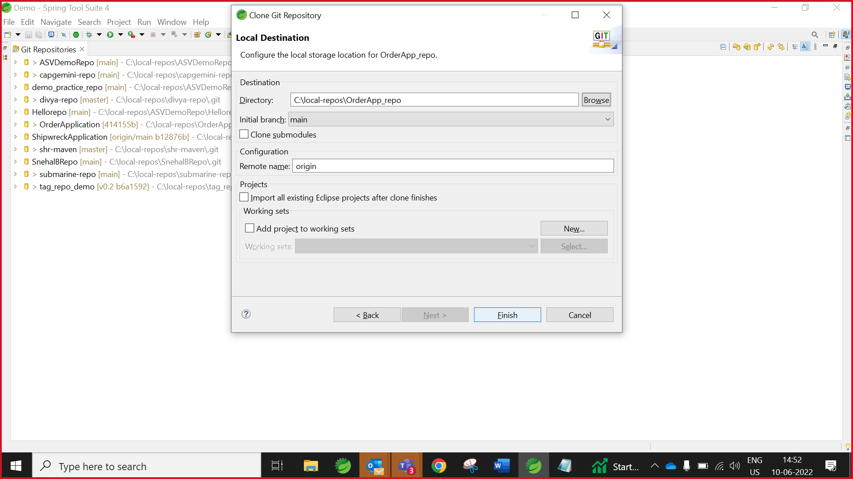

## **Import maven project**

1. Go to git Repositories expand the Project Repositories/Working Tree Right click on project name and select “**Import Projects**”

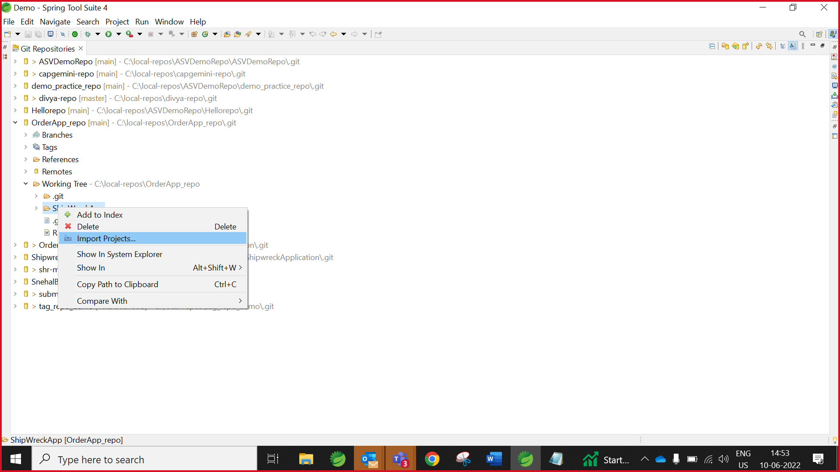

1. Select the Folder directory in which you want to Import the project and click “Finish “

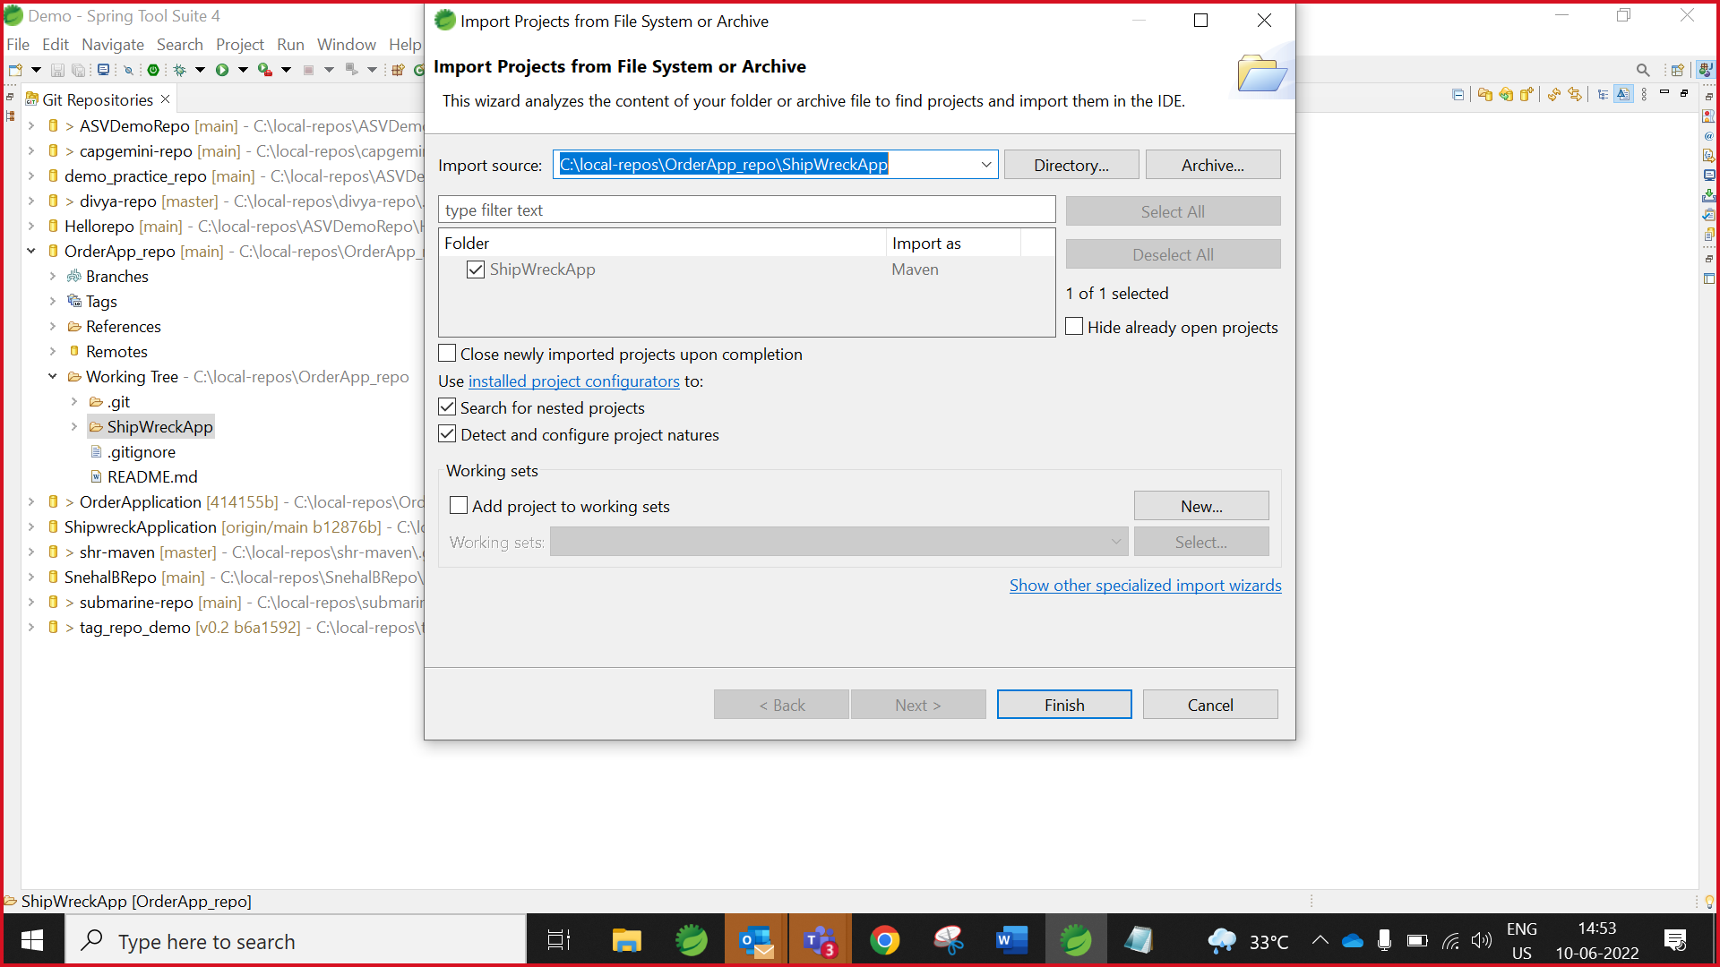

1. Project Imported Successfully we can see it in Project Explorer.

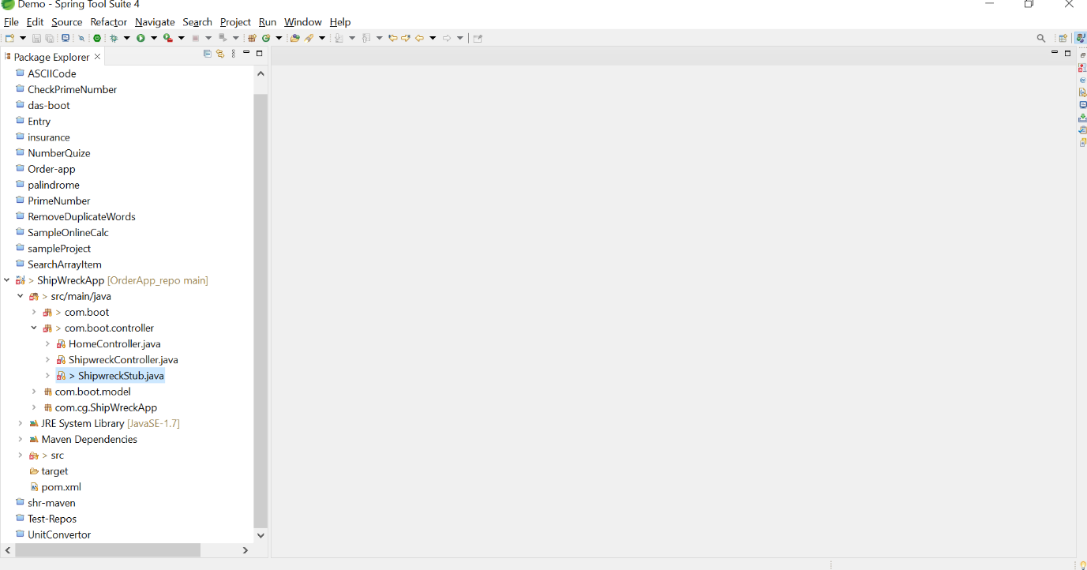

1. Right click on project and select “Close Unrelated Projects”

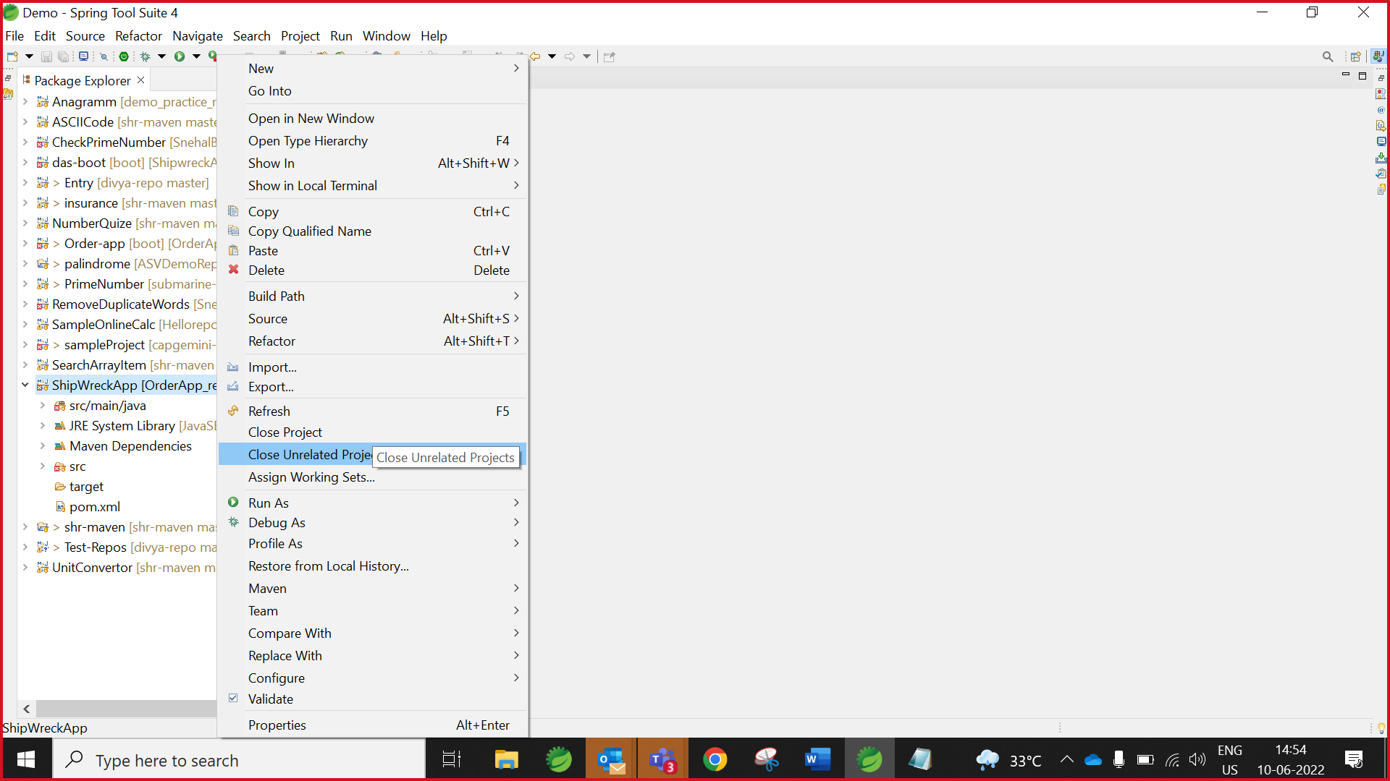

1. Click **Close**

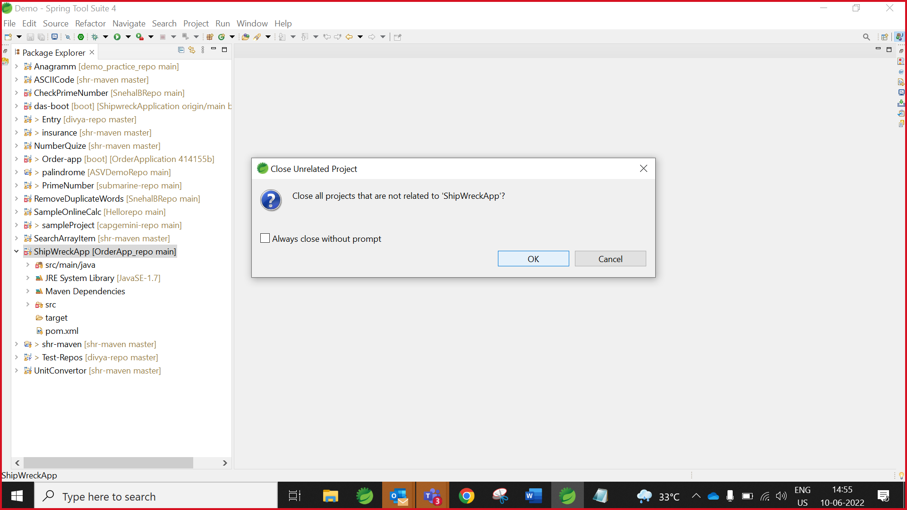

1. Click on the search symbol on right top and in the filter text box enter Tasks, Under General, select Tasks.

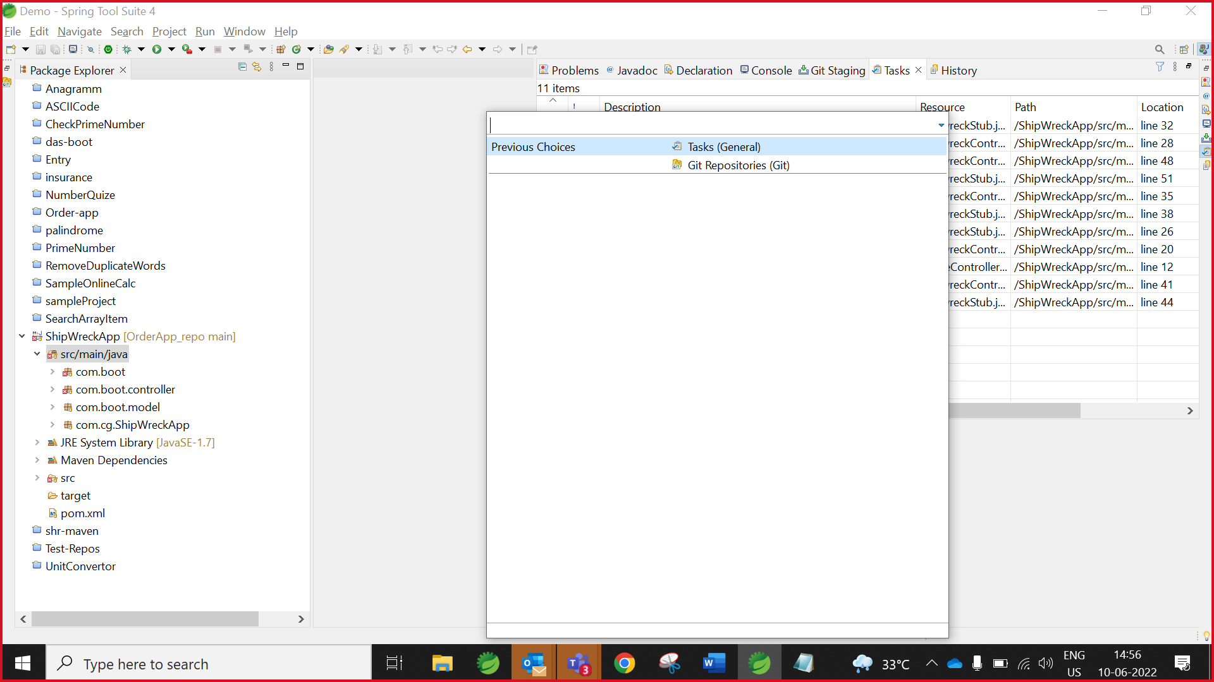

1. The Tasks view can be used to view all the TODO’s.

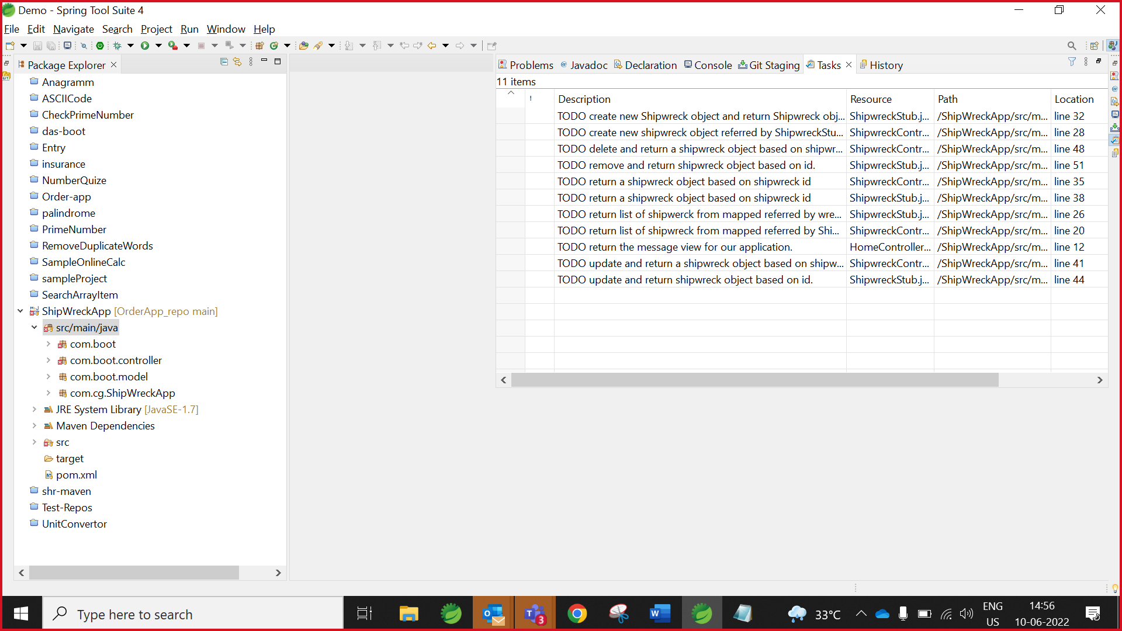

1. After Double Click on TODO it will redirect you on task page.

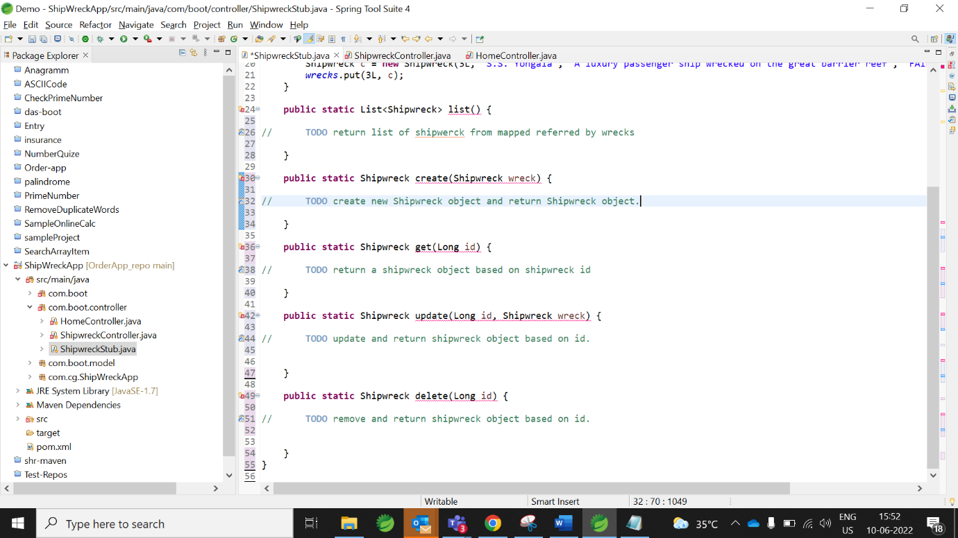

1. Collaborator should complete all tasks.

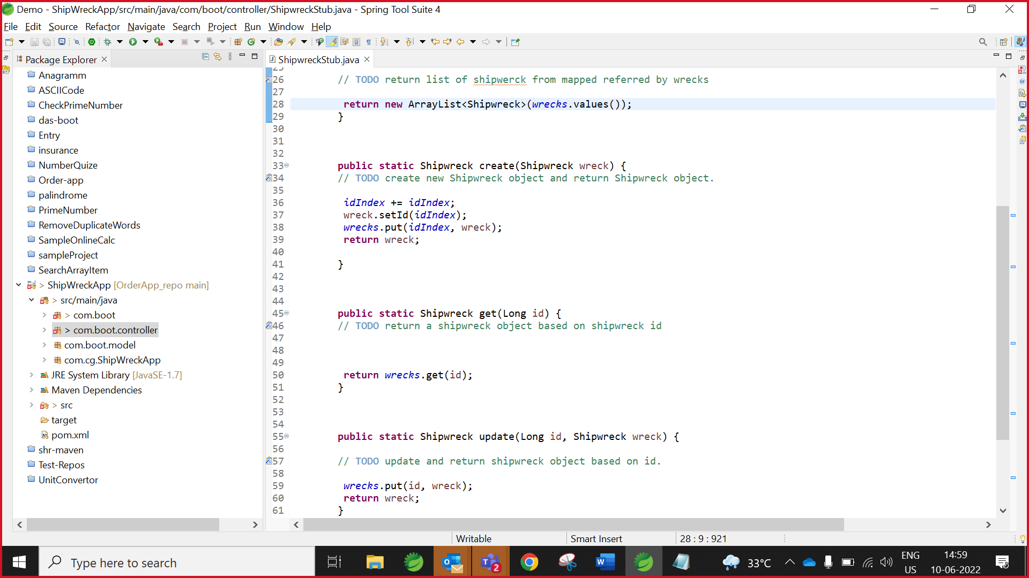

## **Collaborator Push Request**

1. Please refer “push Code to GitHub” step.

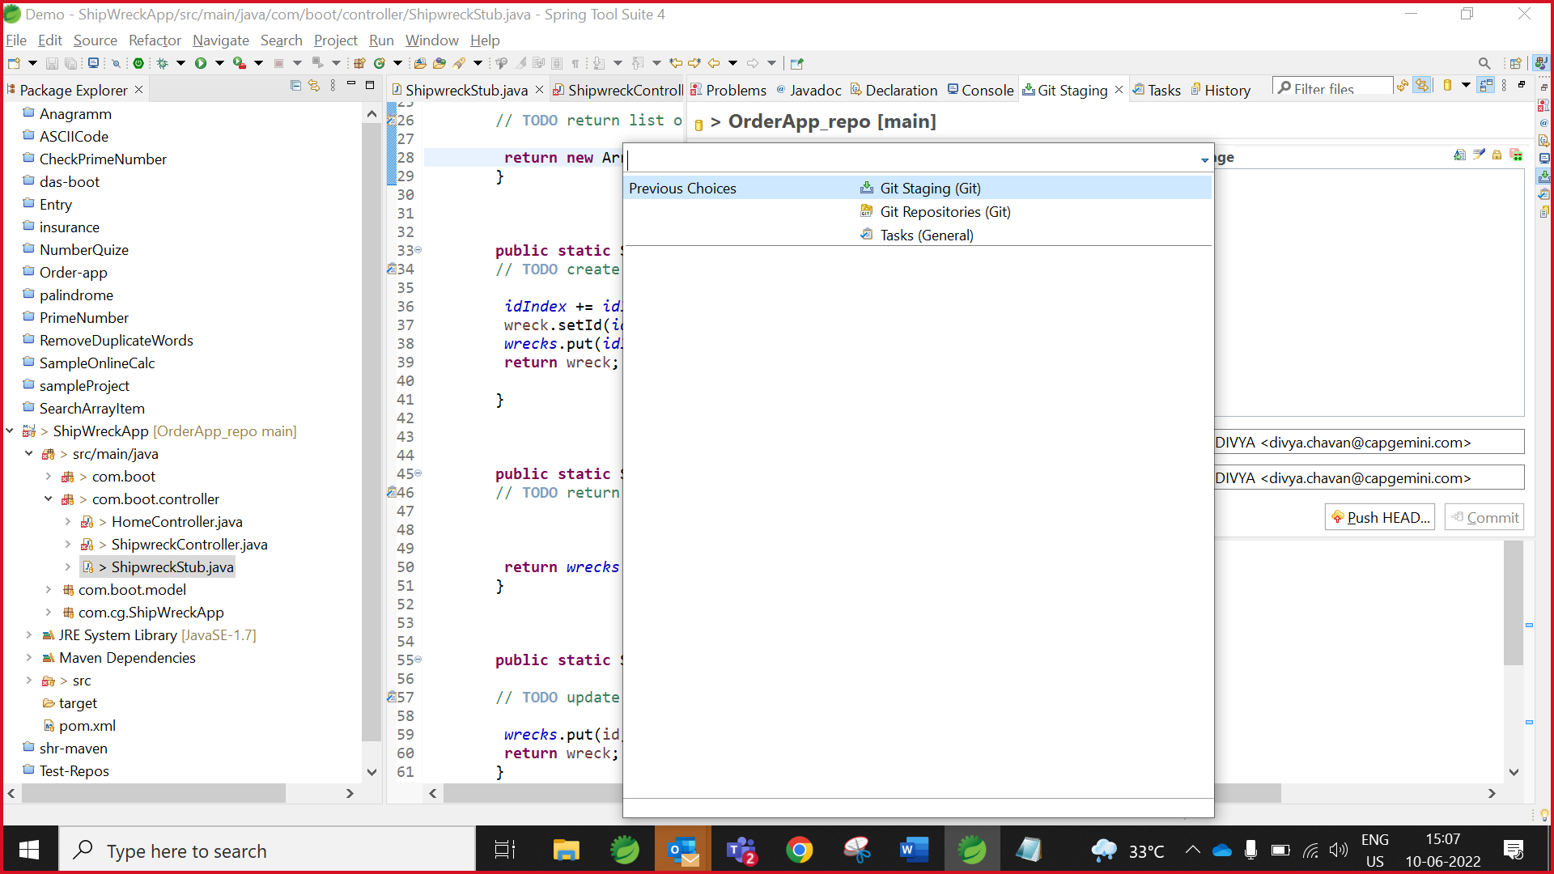

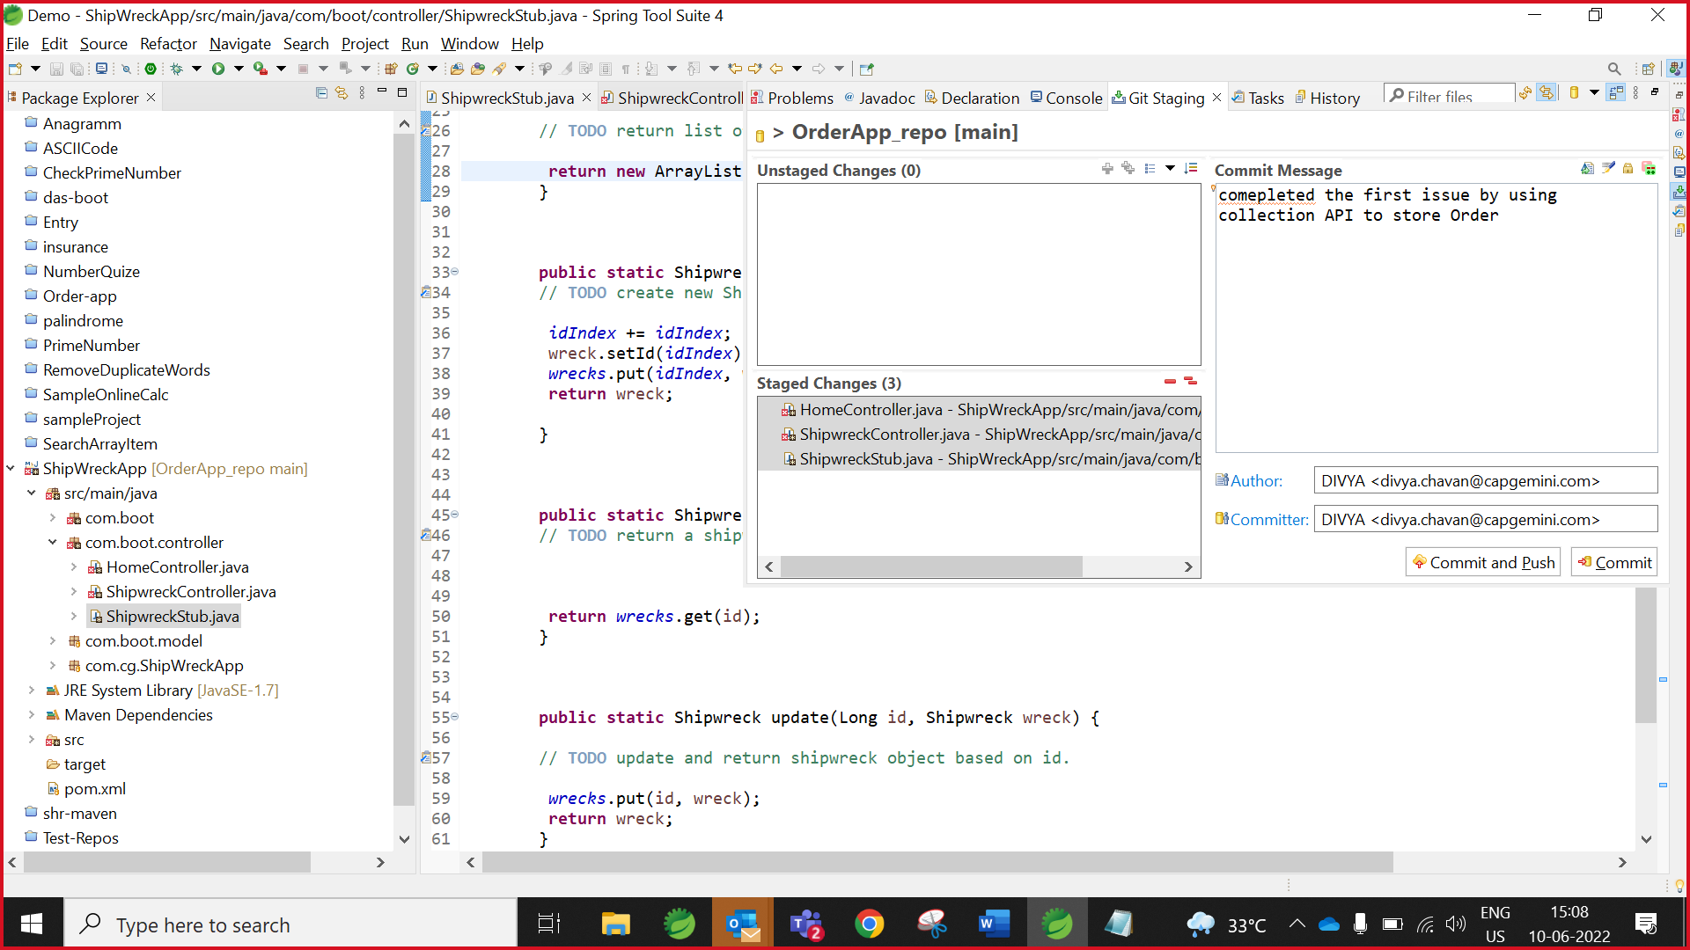

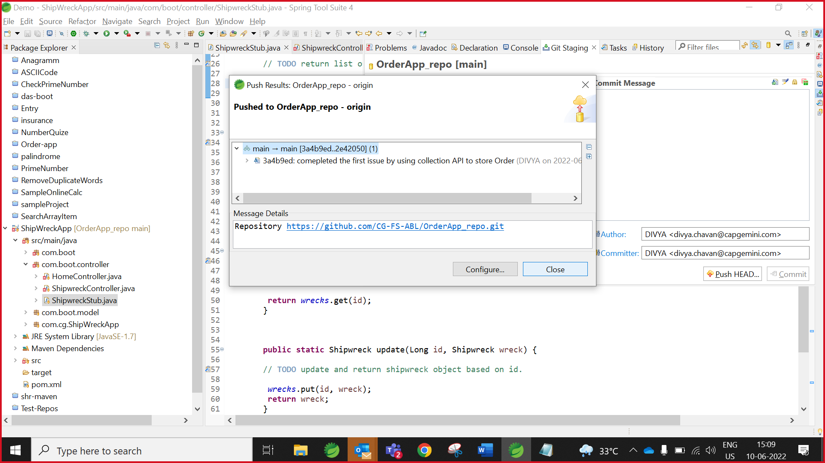

## **Collaborator Create Tag**

1. Please refer the “**Create Tag** “step which mentioned above.

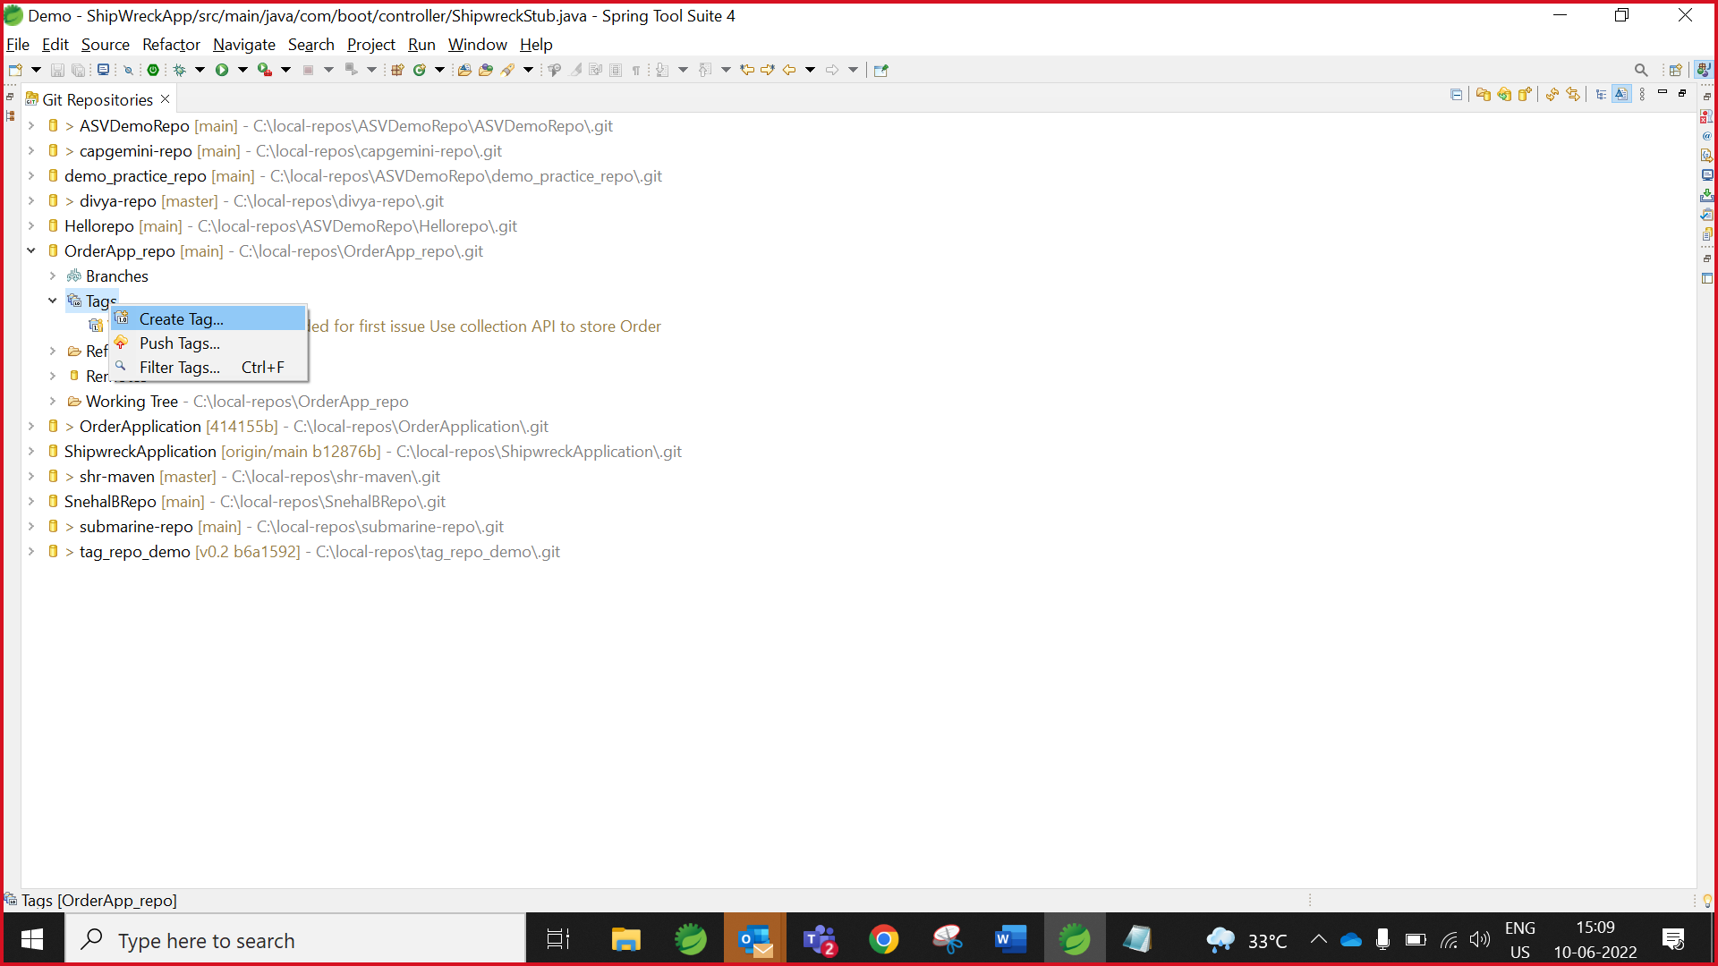

1. Create tag.

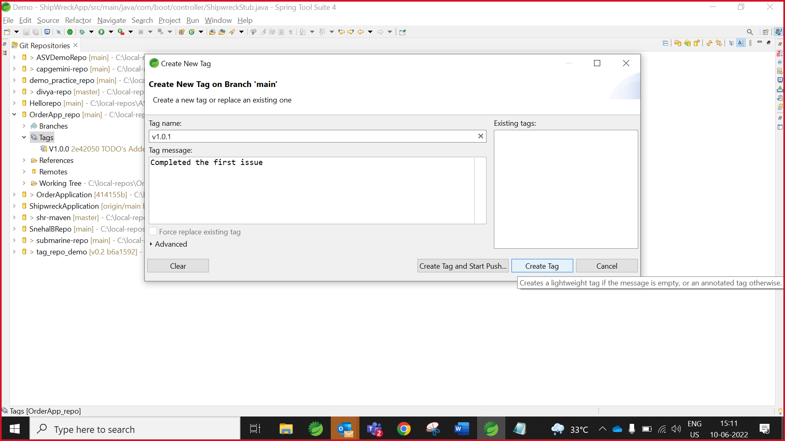

1. Push tag.

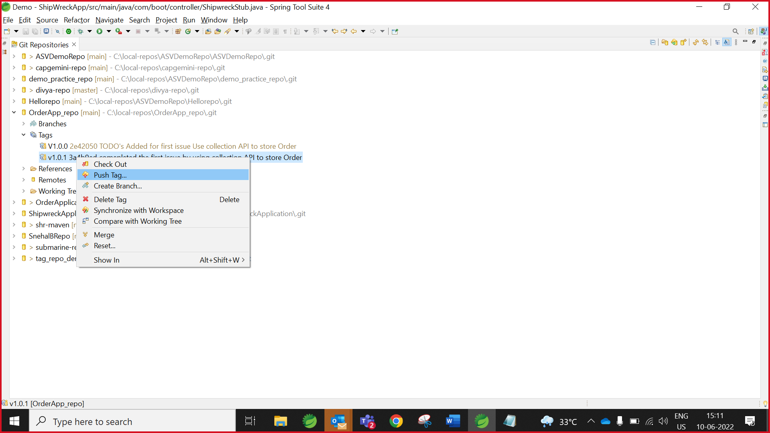

Note: After creating the tag V1.0.1 for instance, you need to Push the tag to the repository

1. Click preview

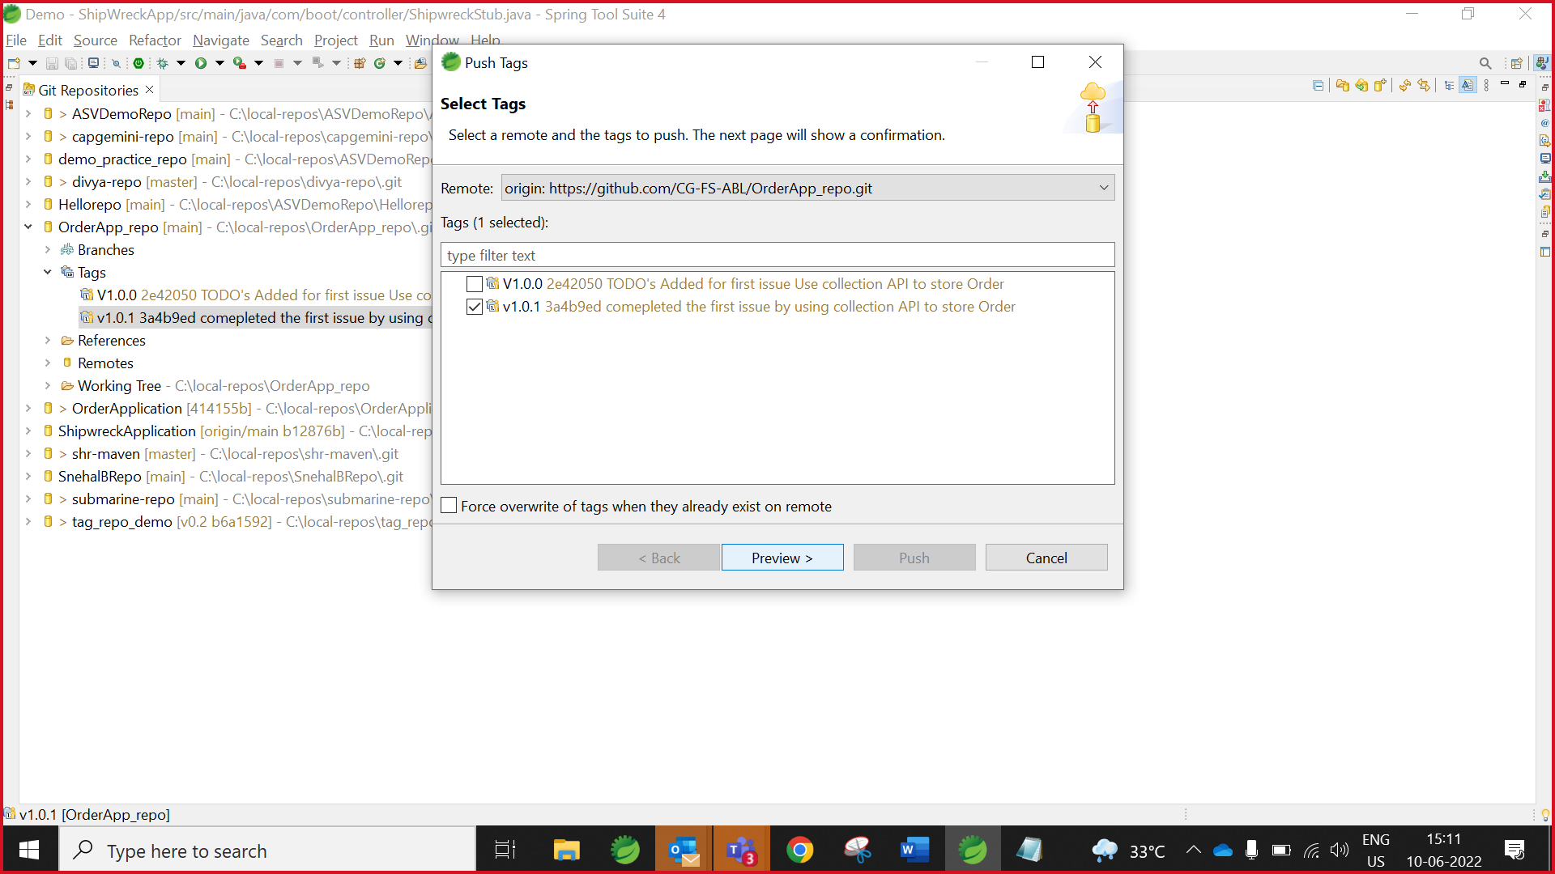

1. Click Push.

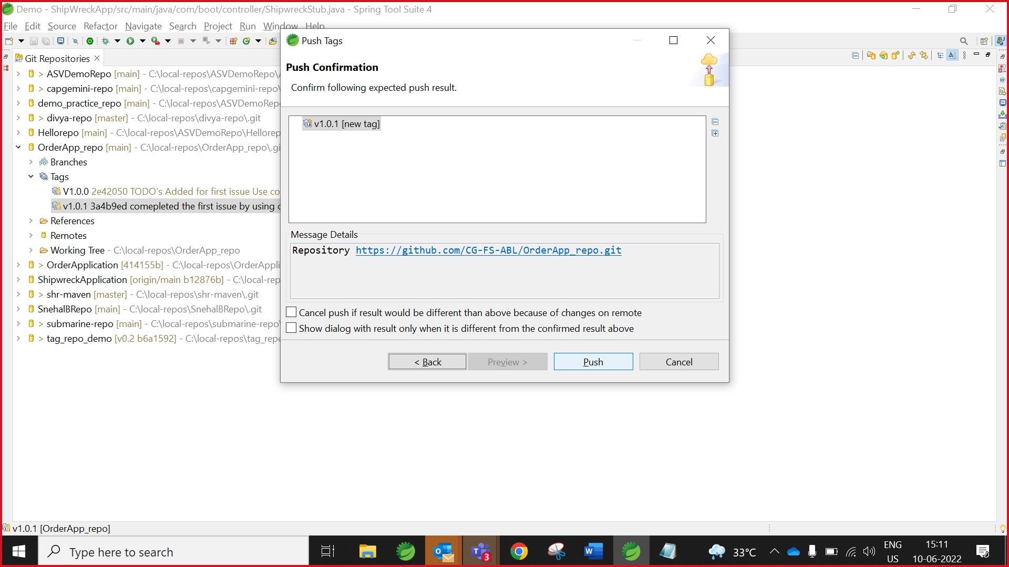

**Note: Activity Completed Successfully repeat the same steps for second issue.**